E-CLINIQ

Project Documentation Submitted to the Faculty of the

School of Computing and Information Technologies

Asia Pacific College

In Partial Fulfillment of the Requirements for

Systems Analysis and Detailed Design for MCSPROJ

By

|  |  |
| --- | --- |
| *Churchill Campagna* | *John Angel Manahan* |
| *Darcy Kaizer Medina* | *Kurt Jordan Cadenas* |
| *Jan Patrick Navarrete* |  |

ASIA PACIFIC COLLEGE

Approval Sheet

**E-CLINIQ**

Prepared and submitted by

Churchill Capagngan

Darcy Kaizer Medina

Jan Patrick Navarrete

John Angel Manahan

Kurt Jordan Cadenas

In Partial Fulfillment of the Requirements for the Degree of

Bachelor of Science in Computer Science

Examined and Recommended for Acceptance and Approval for

Research/Capstone Presentation

___________________________

Roselle Wednesday L. Gardon, *Adviser*

**Panelists**

___________________________

Manuel L. Calimlim, Jr.

|  |  |
| --- | --- |
| ___________________________ | ___________________________ |
| Manuel Sebastian S. Sanchez | Lorena Rabago |

Acceptance and Approved in Partial Fulfillment of the Requirements for the Degree of

Bachelor of Science in Computer Science

___________________________

Rhea-Luz R. Valbuena

Executive Director

School of Computing and Information Technologies

Table of Contents

Executive Summary 3

List of Figures 4

List of Tables 5

I. Introduction 6

1.1. Project Context 7

1.2. Statement of the Problem 7

1.3. Objectives 7

1.4. Significance of the Project 8

1.5. Scope and Limitations 8

II. Review of Related Literature / Systems 9

2.1. Standard Systems for School Clinics 10

2.2. Existing Health Record Systems 10

2.3. Existing Scheduling Systems 11

2.4. Synthesis 11

III. Technical Background 11

3.1 Current System 12

3.2 Proposed System 12

IV. Theoretical Background 12

V. Methodology 13

5.1 Requirements Analysis 13

5.1.1 Product Backlog / User Stories 13

5.1.2 Event Tables 15

5.1.3 Use Case Diagrams 17

5.1.4 Use Case Full Description 18

5.2 Gap Analysis 24

5.3 System Analysis and Design 25

5.3.1 Context Diagram 26

5.3.2 Data Flow Diagrams 26

5.3.3 Entity-Relationship Diagrams 31

5.3.4 Activity Diagrams 32

5.3.5 Object Diagrams 33

5.3.6 Class Diagrams 33

5.3.7 Sequence Diagrams 35

5.3.8 State Machine Diagrams 36

VI. Results and Discussion 37

6.1 Release Plan 38

6.2 Prototype 38

6.3 Use Classes and Characteristics 42

VII. Conclusion 43

References 44

Appendices 45

Appendix A: Project Vision 46

Appendix B: Schedule 46

Appendix C: Product Roadmap 53

Appendix E: Team Meetings 56

Appendix F: Source Code 64

# Executive Summary

In this project, this group aims to solve their client’s problems and attempts to improve their current system. The client, Asia Pacific College (APC)'s clinic, has expressed concerns over the clinic’s processes, specifically the current health record and inventory system and a missing scheduling system. Their current systems are paper based and involve physical records stored in folders placed in filing cabinets. This kind of system is subject to time-consuming management and is quite difficult to organize. The proposed solution, E-CLINIQ, will make managing patient appointments and records at the clinic easier and faster. To develop the proposed solution, we used the design thinking methodology to ensure that the solution is centered around the users and designed the application’s diagrams as a basis for coding development. The developed prototype shows how the group took the received user feedback and adjusted the application accordingly.

# List of Figures

Fig. 1 Use Case Diagram 12

Fig. 2 SWOT Analysis 19

Fig. 3 Context Diagram 20

Fig. 4 Data Flow Diagram Level 0 21

Fig. 5 Data Flow Diagram Level 1 Page 1 22

Fig. 6 Data Flow Diagram Level 1 Page 2 23

Fig. 7 Data Flow Diagram Level 1 Page 3 24

Fig. 8 Entity Relationship Diagram 25

Fig. 9 Activity Diagram 1 26

Fig. 10 Activity Diagram 2 27

Fig. 11 Object Diagram 27

Fig. 12 Class Diagram 1 28

Fig. 13.1 Class Diagram 2 28

Fig. 14 Sequence Diagram 29

Fig. 15 State Machine Diagram (Patient Appointment) 30

Fig. 16 State Machine Diagram (Patient Records) 30

Fig. 17 Landing Page 32

Fig. 18 Patient Login 32

Fig. 19 Appointment 33

Fig. 20 Clinic Login 33

Fig. 21 Clinic Home Page 34

Fig. 22 Patient Records 34

Fig. 23 Update Schedule and Time 35

Fig. 24 Medical Clearance 35

Fig. 25 Project Vision for APC Clinic 39

Fig. 26 Gantt Chart (Page 1) 40

Fig. 27 Gantt Chart (Page 2) 41

Fig. 28 Gantt Chart (Page 3) 42

Fig. 29 Gantt Chart (Page 4) 43

Fig. 30 Gantt Chart (Page 5) 44

Fig. 31 Gantt Chart (Page 6) 45

Fig. 32 Gantt Chart (Page 7) 46

Fig. 33 First Meeting with Nurse Ana Mae Torre (April 29, 2022) 52

Fig. 34 Second Meeting with Nurse Ana Mae Torre (May 18, 2022) 52

Fig. 35 First Meeting with Project Adviser, Doc Manny (May 19, 2022) 53

Fig. 36 Second Meeting with Project Adviser (May 30, 2022) 53

Fig. 37 Third Meeting with Project Adviser (June 3, 2022) 54

Fig. 38 Physical Meeting with Project Adviser (June 6, 2022) 54

Fig. 39 Project Discussion on Whiteboard (June 6, 2022) 55

Fig. 40 Meeting with Technical Consultant, Sir Jayvee (June 10, 2022) 55

Fig. 41 Meeting with Subject Adviser, Ms. Roselle (June 13, 2022) 56

Fig. 42 Meeting with Clinic Administrator, Sir Jojo (June 14, 2022) 56

Fig. 43 Meeting with Project Adviser (June 21, 2022) 57

Fig. 44 Meeting with Clinic Administrator (June 22, 2022) 57

Fig. 45 GitHub Repository 58

# List of Tables

Table 1 Product Backlog / User Stories 7

Table 2 Event Table 9

Table 3 Use Case Table: Login 12

Table 4 Use Case Table: Set Appointment 13

Table 5 Use Case Table: Request Medical Clearance 14

Table 6 Use Case Table: Set Up Health Record 15

Table 7 User Roles and Description 30

Table 8 Minutes of the Meeting 39

# Introduction

## Project Context

Delivering high-quality patient care today depends on accurate and effective health record management. In the past, many healthcare facilities depended on paper-based record systems, which were labor-intensive, prone to error, and complicated for healthcare personnel to quickly access patient information.

First, making and keeping written records can take a lot of time because they must be manually filed by hand. This can lead to mistakes, like missing or repeated information, which can lead to wrong evaluations and treatments. Second, paper records are usually kept in actual filing boxes, which can take up a lot of room and require a lot of work to get out and move. Third, paper records are more likely to be damaged by natural disasters or mistakes made by people, such as fires, floods, or loss by accident. Lastly, paper records can make it hard for health care workers to get information about a patient quickly, since they may have to wait for the record to be physically brought out of storage. Due to these problems, health record handling must be done more modernly and efficiently, such as using an Electronic Health Record (EHR) system.

Electronic Health Record (EHR) systems, which enable quicker, more accurate, and more secure record-keeping, have been used by many clinics in recent years. These databases frequently contain information on the patient's demographics, medical history, current prescriptions, lab and radiological results, and other crucial clinical data. By giving doctors real-time access to patient information, wherever the patient is receiving care, EHR systems are intended to enhance patient outcomes, minimize mistakes, and streamline workflows. As a result, many clinics are spending money on EHR systems as an essential part of their total healthcare technical infrastructure. This is why the project’s client, Asia Pacific College's Clinic, wanted an upgrade on their current paper-based system. The nurse experienced the disadvantages of their current system first-hand. Therefore, the project’s goal was to digitize the current health record system while integrating an appointment and inventory system as an innovation for the new system.

## Statement of the Problem

Asia Pacific College's clinic has expressed concerns over the clinic’s processes, specifically the current health record system which takes up space in the clinic and missing an appointment scheduling system and a digital inventory system. The current health record system involves physical records stored in folders placed within file cabinets.

Client Pain Points about the current system:

1. Managing the health records and inventory is time consuming.
2. Physical records consume clinic space unnecessarily.
3. Walk-in patients are not guaranteed an immediate consultation with the doctor.
4. Patients are not instantly updated when their appointment is cancelled.
5. The generation of summary reports of services is time consuming.

## Objectives

To develop a clinic management system that organizes and maintains patient records, appointments, and medicine inventory. So that…

Specific Objectives:

1. To provide a tool to digitize patient records.
2. To allow users to set appointments and be notified of appointments.
3. Generate digital reports of Monthly Accomplishments and Inventory.

## Significance of the Project

This project will help the APC Clinic address the concerns over the current system because our application will ease and speed up the clinic’s processes of managing records and provide an appointment scheduling system.

The following people will benefit from the project:

* Nurse – The digitized health record system will allow them to have quick and easy access to the health records where they can instantly manage them anywhere there’s internet connectivity. The instant generation of summary reports of services and its analysis will let them allot their time into other deliverables. They will also be able to better manage the patients’ appointment schedules and instantly contact the patients if there are sudden appointment adjustments.
* Clinic Administrators – The project will provide better customer service and experience, which will fulfil the clinic administrator’s mission and vision. They will receive analytics based on the summary reports of services generated by the system.
* Students and Employees – This project helps them to become more aware of their appointments at the clinic and they will be quickly notified via SMS (Short Message Service) if their appointment is cancelled due to specific reasons.

## Scope and Limitations

This project aims to focus and provide solutions to the APC Clinic’s concerns regarding their current health record and scheduling system.

**Scope:**

The focus of this project is to provide a digitized solution for APC Clinic’s current health record system and scheduling system.

The range of the features of the proposed system includes:

* Create, read, update, delete (CRUD) functions for managing health records and appointments.
* A virtual consultation form wherein the remarks can serve as a means of recording treatment and procedures done to the patient.
* An operating-hours feature wherein the nurse can update the operating hours of specified dates so that the system can prevent any appointments from being set during non-operating hours.
* A direct scheduling function for follow-up consultations
* An email feature that notifies students/employees about their appointment schedule and updates them if their appointment is cancelled due to stated reasons.
* A direct rescheduling function when the nurse decides to cancel an appointment.
* A generated summary report of clinic services.
* Application Programming Interface (APIs) that connects the system to the Registrar and HR system to perform data extraction needed to pull out the patient’s name and course or department for students and employees, respectively.

**Limitation:**

The application shall provide analytics with basic insights on the clinic services (clinic visits, clinic cases sent to the hospital, ward admissions). The developers will not complete data input for the health records during the implementation of the project, this task would befall on the clinic staff as they have administrative privileges when it comes to managing sensitive health records of the students. Medical staff, such as dentists and doctors, outside the school would require approval from one of the personnel in the clinic to access the students’ health records for privacy reasons.

# Review of Related Literature / Systems

In this chapter, the paper examines and synthesizes related projects relevant to making this project. The researchers gathered related studies here to compare the project to existing related systems.

## Standard Systems for School Clinics

Digital technology revolutionized the health record system as clinics, hospitals, and other medical offices now have digital Health Record Systems (HRS). Because of their efforts, patient care, patient involvement, care coordination, diagnostics, and patient outcomes have all improved. Efficiencies and cost savings [1].

All registered professional school nurses should have access to a software platform for student electronic health records (EHRs) that includes nursing language/medical terminology and complies with standards of confidentiality, security, and privacy, according to the National Association of School Nurses (NASN). Interoperability of records with other members of the healthcare and school-based teams helps students and populations achieve their best health and academic results [2].

ORDBA was produced in 2018 as an openEHR benchmark dataset for evaluating the performance of electronic health record servers. It illustrated how ORBDA benchmarks the inserting throughput and query latency of NoSQL database management systems. The results show that even the lowest performing health record server can execute search queries in milliseconds which goes to show that even the proposed project can execute search queries in less than 5-10 seconds especially since, the application will be use Amazon’s Web Services [3].

## Existing Health Record Systems

SchoolDoc is a popular school-based electronic health record (EHR) system. Their safe and easy-to-use web-based solutions are designed for school nurses and directors, which maintains health forms, allergies, medications, and illness/injury tracking for the school throughout the year [4].

This existing system relates to our project because SchoolDoc allows school nurses and administrators to quickly access critical student health information. This covers allergies, medications, and immunization data for students and employees. They can also keep track of medical administration and keep an electronic health diary of sickness and injuries. The management and analytics of these health records are both a goal on this project, however, our project also involves a scheduling system where appointments have organized visualization that allows for the nurse to manage and properly schedule non conflicting appointments.

EduHealth is one of the most popular electronic health record systems for school nurses, and it assists them in keeping students and the school environment safe. Its features enable comprehensive student care by breaking down school nurses' everyday activities into easy-to-use modules, allowing them to stay in complete control of their responsibilities. The system is cloud-based, allowing school nurses to manage essential health facts from a remote location [5].

EduHealth differs from SchoolDoc and our project as the system focuses heavily on tracking and managing the students’ medication, treatment, and health screening. It also focuses heavily on tracking the immunization and contact tracing of the students. They have features that deeply analyze students’ medical and health history, medication management, treatment management, health screening management, medication reorder management, and far more on the student profile.

## Existing Scheduling Systems

SimplyBook.me provides clinics with their own online booking system so patients may make appointments at any time. In the application the clinic can set working hours, break times, and holidays for all your employees, and keep track of everything from your web dashboard. This type of appointment system is appropriate for doctors, dentists, private practices, clinics, and anybody else who wants to accept bookings [6].

Other existing scheduling systems also offer the features that are already available in SimplyBook.me, these applications, Qmatic and DocPulse, also successfully developed a booking system where they improved the reducing of waiting times for patients and the cancellation of appointments. These systems have meticulously organized appointment schedules that create a happier working environment for the doctors and nurses [7] [8].

SimplyBook.me, Qmatic, and DocPulse focus on booking and managing appointments which relates to our project that also aims to digitize the scheduling system for student appointments. However, our project differs from SimplyBook.me and these related systems in terms of scope because their system involves contact tracing management when booking appointments.

## Synthesis

After reviewing and comparing these related systems to our own project, it has built a solid foundation for its development. The studies that the researchers have gathered provided an existing need for clinics to have an electronic health record system which allows nurses to manage and analyze the students’ health records. The existing health record systems set standards for our project development that the proponents aim to meet especially in organizing medical data of the students to analyze and create insights about the students’ well-being. The existing scheduling systems have also provided the need for digitizing the scheduling of appointments in which is benefits both the nurse and the patient by reducing waiting times and cancelled or “no-show” appointments. These related literature and systems gave this project a sense of need and projected benefits for our client and the institution of Asia Pacific College. 

# Technical Background

The technical background on the subject is provided in this chapter, together with relevant concepts, technologies, and standards. It is meant to provide the reader with a basic overview of the subject and to set the stage for the study or advancement that will be discussed in the following chapters. The chapter starts out with a summary of the major ideas before getting into technical specifics on the technologies and standards utilized in the project.

## Current System

APC's present health record system uses pen and paper to create health records, and then placed within a physical folder created for each student and stored in filing cabinets. They send emails to the students about their schedule details in terms of scheduling appointments. The nurse records each appointment details in a logbook to organize and review when they will set up a new appointment to avoid overlapping schedules.

## Proposed System

E-CLINIQ will digitize the processes of the current health record and scheduling system. This application can quickly create, read, update, and delete students’ health records and keeps each record safe from data loss. The application has its own appointment scheduler, and it also records the appointment details along with the students’ health records. The application can also generate reports for specific time periods (days, weeks, months, and/or years), and it also comes with simple analytical insights based on the students’ health records.

The developers will store the application in the existing AWS server that APC is currently using, and it will be accessible to desktops, laptops, mobile phones, or any device that has a browser installed. Amazon’s security solutions for their servers ensured the security of the students’ health records and appointment details. Amazon’s Simple Notification Services (SNS) will send text notifications to students informing them of their appointment details. The developers used HTML, CSS, and JavaScript for the application’s front-end, and PHP and MySQL for the application’s back end. PHP allows the developers to access different frameworks, databases, and libraries essential to the application. We also connected the application to the existing authentication server that APC currently uses for their RAMS Portal using API. The developers plan to connect their application using APIs to the existing systems of APC specifically the Registrar and HR system to perform data extraction needed to fill out patient records.

# Theoretical Background

Several significant concepts are present in the theoretical underpinnings of such a system, including:

* **Electronic Health Records (EHRs)**: EHRs are digital equivalents of paper patient files that offer a more accurate and efficient way to store and transmit patient data. EHRs frequently contain clinical data such as test results, medical history, medicines, allergies, and demographic data.
* **Appointment Scheduling**: Online, patients may make and modify appointments using the appointment scheduling section. These systems frequently provide functions like online booking, real-time schedule changes, and appointment reminders.
* **Data privacy and security**: Protecting a patient's private health records is of the highest significance. Systems for managing appointments and electronic health records should be built to guard against unauthorized access to, alteration of, or disclosure of patient data.
* **Dashboard and reporting**: With the aid of a dashboard and reporting feature, healthcare professionals could quickly review a patient's medical history and upcoming appointments, monitor, and assess the clinic's performance, and make data-driven decisions to enhance both the patient's experience and the clinic's overall performance.

# Methodology

We formulated the project’s problem and goal based on our client’s issues of the current systems in the APC Clinic in SNTSDEV. We enhanced our project through the design thinking methodology wherein we take in user inputs on our initial prototype and make changes based on that feedback in SSYADD1. Finally, the team began developing the proposed system using the initial diagrams made during SSYADD1 which were the data flow diagram, user stories, and the entity relationship diagram in SCSPROJ. The makings of other diagrams were made during that development.

## Requirements Analysis

### Product Backlog / User Stories

Table 1 Product Backlog / User Stories

|  |  |  |  |  |
| --- | --- | --- | --- | --- |
| **User stories** | | | | |
| **ID** | **As a…** | **I want to be able to…** | **So that…** | **Priority** |
| 1 | Clinic Administrator | Receive monthly reports of services | I can monitor the clinic’s processes | Must |
| 2 | Nurse | Send the schedule of the appointment to the student/employee. | I can inform students of their appointment schedule | Must |
| 3 | Nurse | Instantly schedule follow-up consultation if necessary | I can inform students and let them clear their schedule to attend the important follow-up consultation | Must |
| 4 | Nurse | Access the health records even when I am not present in the office. | I can still be productive when working from anywhere | Must |
| 5 | Nurse | Instantly search and update a health record | I can quickly manage the health records | Must |
| 6 | Nurse | Instantly generate summary reports of services | I can have more time to double check the information and a lot more time in other clinical work | Must |
| 7 | Students | Receive updates for the appointment schedules via email | I can avoid being late or absent to an appointment and being informed when my appointment is to be cancelled due to specific reasons. | Must |
| 8 | Employees/ Faculty/ Staff | Receive updates for the appointment schedules via email | I can avoid being late or absent to an appointment and being informed when my appointment is to be cancelled due to specific reasons. | Must |

### Event Tables

Table 2 Event Table

|  |  |  |  |  |  |
| --- | --- | --- | --- | --- | --- |
| **Event** | **Trigger** | **Source** | **Use Case** | **Response** | **Destination** |
| 1. Patients' physical check-up and medical examination | Visiting the clinic for the first time. | Patient | Set up Patient Record | -Fill out consultation form | Nurse  System |
| 1. Manage Medical or Dental Report |  | Doctor  Dentist | Manage Medical or Dental Records | -Create  -Update  -View | System  Nurse  Patient  Doctor  Dentist |
| 1. Requests for documents | Request Page | Nurse  Patient | Request Documents | -Request Details  -Student uploads documents  -Nurse receives supporting document  -Documents are listed in the profile page | Patient  Nurse |
| 1. Appointment management. | Appointment Page. | Nurse.  Patient. | Manage Appointments | -Schedule details  -Request Appointment  -Confirmation of details.  -Shows appointment time and date.    -Can cancel appointment  -Appointment cancel notice | System.  Patient.    System  Nurse.  System  Patient  Nurse  Patient  System  Patient  Nurse |
| 1. Inventory Management. | Inventory Page | Nurse. | Manage Inventory | -Add items  -Update items  -View items  -Create inventory report  -View inventory report  -Request for medicine and supplies replenishment | System.  Nurse.  Clinic Administrator. |
| 1. Time to produce medical reports. | End of the month report |  | Generate Reports | -monthly accomplishment reports | Nurse  Doctor  Dentist |

### Use Case Diagrams

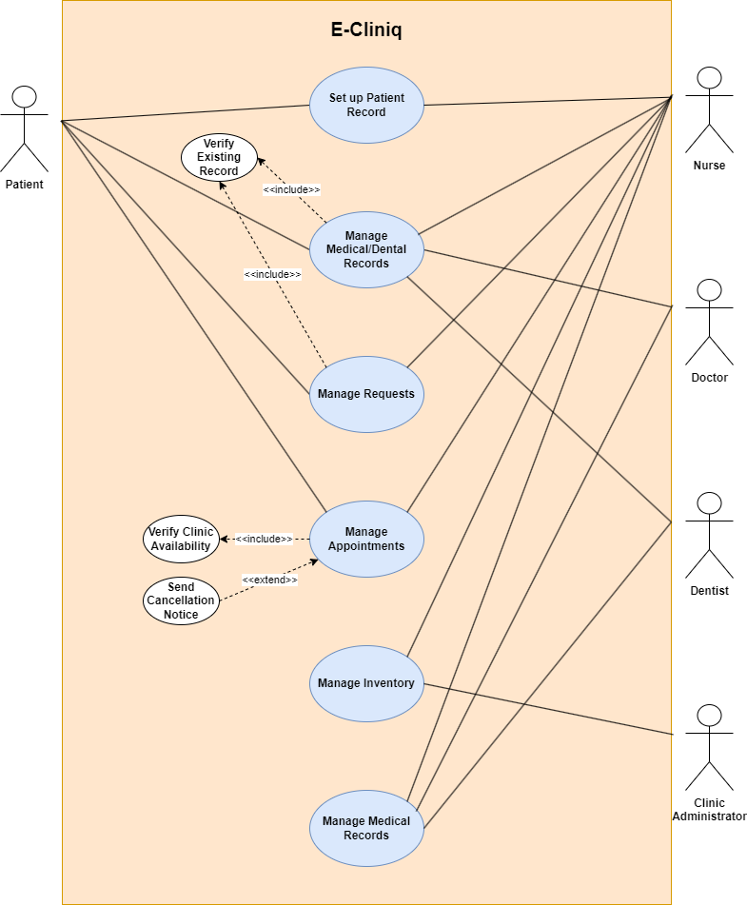

Fig. 1 Use Case Diagram

### Use Case Full Description

**Brief format Use Case**

Set up Patient Record: Patients who are recently enrolled/employed will go to the clinic for the first time and will be fill out a consultation form that contains their basic patient details and the nurse records the student’s vital signs with remarks on the same form.

Manage Medical or Dental Records: The doctor interviews the student for health history and performs the required physical check-up which will be recorded in the Medical Examination Report. The dentist conducts dental check up on the student and records the data in the Dental Examination Record.

Request Documents: The nurse can send a document request to the patient for any needed supporting medical documents, and the Patient can fulfill this request by uploading the requested document.

Manage Appointments: The nurse can set the schedule that matches the clinic’s availability in the system. Both the nurse and patients will be able to set appointments to the clinic which the nurse can access and confirm, and the set appointment schedule will be sent to the doctor if needed. Once it is confirmed, the official appointment time and date will be shown to the patient and nurse. It is also possible for both the nurse and patients to cancel the appointment if necessary, and the cancellation notice will be seen in the system and by the nurse.

Manage Inventory: The nurse can add, update, and view inventory items in inventory management. The nurse can also create inventory reports that can be viewed by the clinic administrator. The nurse also prepares a purchase requisition that will be forwarded to the clinic administrator for approval and purchasing.

Generate Reports: Not later than the 3rd week of every month, School Nurse prepares a monthly accomplishment report.

**Casual format Use Case**

Set up Patient Record: Patients who are recently enrolled/employed will go to the clinic for the first time and will be fill out a consultation form that contains their basic patient details and the nurse records the student’s vital signs with remarks on the same form.

*Alternate Scenarios*: Details given are incomplete, Clinic staff will ask patient to complete necessary details.

Manage Medical or Dental Records: The doctor interviews the student for health history and performs the required physical check-up which will be recorded in the Medical Examination Report. The dentist conducts dental check up on the student and records the data in the Dental Examination Record.

*Alternate Scenarios*: Doctor and/or Dentist is unavailable to conduct the necessary examination, patient will be asked to come back later.

Request Documents: The nurse can send a document request to the patient for any needed supporting medical documents, and the Patient can fulfill this request by uploading the requested document.

*Alternate Scenarios*: Details given are incomplete, nurse will ask patient to provide the complete document.

Manage Appointments: The nurse can set the schedule that matches the clinic’s availability in the system. Both the nurse and patients will be able to set appointments to the clinic which the nurse can access and confirm, and the set appointment schedule will be sent to the doctor if needed. Once it is confirmed, the official appointment time and date will be shown to the patient and nurse. It is also possible for both the nurse and patients to cancel the appointment if necessary, and the cancellation notice will be seen in the system and by the nurse.

*Alternate Scenarios*: No medical record has been found; user will proceed with an appointment to set up medical record.

*Alternate Scenarios*: No appointment has been set, user will be sent to set appointment tab.

Manage Inventory: The nurse can add, update, and view inventory items in inventory management. The nurse can also create inventory reports that can be viewed by the clinic administrator. The nurse also prepares a purchase requisition that will be forwarded to the clinic administrator for approval and purchasing.

*Alternate Scenarios*: No medicine was taken in the clinic. No changes in terms of quantity.

Generate Reports: Not later than the 3rd week of every month, School Nurse prepares a monthly accomplishment report.

*Alternate Scenarios*: Nothing to report for the month. Report generated will be blank. Blank report will still be sent.

Table 3 Use Case Table: Set up Patient Record

|  |  |  |
| --- | --- | --- |
| **Use Case Name:** | **Set up Patient Record** | |
| **Scenario:** | Nurse fills up Consultation Form | |
| **Triggering Event:** | Patient will go to the clinic for the first time. | |
| **Brief Description:** | Nurse will ask the patient for details to fill up the Consultation Form | |
| **Actors:** | Patient, Nurse | |
| **Related Use Cases:** | Manage Medical or Dental Records, Request Documents, Manage Appointments, Generate Reports | |
| **Stakeholders:** | Patient, Nurse, Doctor, Dentist. | |
| **Preconditions:** | Patient must have an APC Email  Patient must be enrolled or employed to APC. | |
| **Postconditions:** | Patient will have a record created. | |
| **Flow of Activities:** | Actor | System |
| 1. Patients enrolled or employed will go to the clinic for the first time to fill up a consultation form. 2. The nurse takes the patient’s vital signs and provides necessary remarks. | 1. System receives the consultation form. |
| **Exception Conditions:** | 1. If the patient fails to input all necessary details, the nurse will ask the patient to input the missing details. | |

Table 4 Use Case Table: Manage Medical or Dental Records

|  |  |  |
| --- | --- | --- |
| **Use Case Name:** | **Manage Medical or Dental Records** | |
| **Scenario:** | The doctor conducts a medical history interview and physical check-up, and dentist conducts dental check-up. | |
| **Triggering Event:** |  | |
| **Brief Description:** | Doctor and Dentist fills out the necessary details for the Medical Examination Report and the Dental Examination Record | |
| **Actors:** | Patient, Doctor, Dentist | |
| **Related Use Cases:** | Set up Patient Record, Request Documents, Manage Appointments, Generate Reports | |
| **Stakeholders:** | Patient, Nurse, Doctor, Dentist | |
| **Preconditions:** | Patients must be enrolled in or employed by APC.  Patient must have a record in the clinic | |
| **Postconditions:** | Patients gets a recorded Medical and Dental Examination | |
| **Flow of Activities:** | Actor | System |
| 1. Doctor conducts medical history interview and physical examination of the Patient. 2. Doctor finalizes the Medical Examination Report. 3. Dentist conducts Dental Examination 4. Dentist finalizes the Dental Examination Record 5. Doctor and Dentist updates the Medical Examination Report and Dental Examination Record when necessary. 6. Doctor and Dentist views the Medical Examination Report and Dental Examination Record when necessary | 1. System saves the Medical Examination Report 2. System saves the Dental Examination Record 3. System receives updates to the Medical Examination Report and Dental Examination Record. 4. System sends the Medical Examination Report when the Doctor requested to view it. 5. System sends the Dental Examination Record when the Dentist requested to view it. |
| **Exception Conditions:** | 1. The doctor and/or Dentist is unavailable to conduct the necessary examination, patient will be asked to come back later. | |

Table 5 Use Case Table: Request Documents

|  |  |  |
| --- | --- | --- |
| **Use Case Name:** | **Request Documents** | |
| **Scenario:** | Nurse wants to request a medical document | |
| **Triggering Event:** |  | |
| **Brief Description:** | Nurse will request necessary supporting medical documents from the Patient | |
| **Actors:** | Patient, Nurse | |
| **Related Use Cases:** | Set up Patient Record, Manage Medical or Dental Records, Generate Reports | |
| **Stakeholders:** | Patient, Nurse | |
| **Preconditions:** | The nurse must be logged in to the E-Cliniq Web App.  Patients must have an existing record in the clinic. | |
| **Postconditions:** | Scanned Requested Document | |
| **Flow of Activities:** | Actor | System |
| 1. Nurse sends the request details to the Patient for the required documents. 2. Patients receive the request details. 3. Patient uploads the requested document. 4. The nurse receives the requested document. | 1. The system sends the request details of the nurse to the patient. 2. System receives the uploaded documents from the patient. 3. System sends the requested document to the nurse. 4. System lists the submitted documents to the profile page. |
| **Exception Conditions:** | 1. Details given are incomplete, nurse will ask patient to provide the complete document. | |

Table 6 Use Case Table: Manage Appointments.

|  |  |  |
| --- | --- | --- |
| **Use Case Name:** | **Manage Appointments** | |
| **Scenario:** | The nurse wants to set clinic schedule availability. | |
| **Triggering Event:** | Nurse clicks on the Appointment page | |
| **Brief Description:** | The nurse sets the availability schedule. Both Nurse and Patient can set or cancel an appointment. | |
| **Actors:** | Patient, Nurse | |
| **Related Use Cases:** | Manage Accounts, Set-up Patient Record, Generate Reports | |
| **Stakeholders:** | Patient, Nurse, Doctor, Dentist | |
| **Preconditions:** | The nurse must be logged in to the E-Cliniq Web App.  Patients must have an existing medical record. | |
| **Postconditions:** | Display success/error message. | |
| **Flow of Activities:** | Actor | System |
| 1. The nurse sets the schedule details. 2. Nurse or Patient requests an appointment. 3. The nurse confirms the details of the appointment. 4. Nurse shows appointment time and date to the Patient. 5. Nurse or Patient cancels an appointment | 1. System saves the schedule. 2. The system verifies if the appointment is non-conflicting, redirects the Nurse or Patient if the date is unavailable. 3. System displays the appointment time and date to the Patient. 4. System sends out appointment cancellation notice to the patient or nurse |
| **Exception Conditions:** | 1. If a patient has no existing medical record, the patient will receive a message that they do not have a medical record in the system and will be asked to set up a medical record. 2. If the date chosen by the patient is not available, the system will show a message and will redirect the patient to the previous tab. | |

Table 7 Use Case Table: Manage Inventory.

|  |  |  |
| --- | --- | --- |
| **Use Case Name:** | **Manage Inventory** | |
| **Scenario:** | Nurse adds items to the Inventory | |
| **Triggering Event:** | Nurse clicks on Inventory Page | |
| **Brief Description:** | The nurse can add, update, or view items in the Inventory. The nurse can also create and send inventory reports along with the purchase requisition. | |
| **Actors:** | Nurse, Clinic Administrator | |
| **Related Use Cases:** | Manage Appointments, Generate Reports | |
| **Stakeholders:** | Patient, Nurse, Doctor, Dentist, Clinic Administrator. | |
| **Preconditions:** | The clinic must have items in their inventory. | |
| **Postconditions:** | Inventory will be updated. Inventory report will be sent. | |
| **Flow of Activities:** | Actor | System |
| 1. Nurse adds items to the Inventory. 2. Nurse updates items in the Inventory. 3. Nurse views items from the Inventory. 4. The nurse creates an inventory report. 5. Clinic administrator views the inventory report. 6. Clinic administrator receives purchase requisition. | 1. The system displays added items. 2. System displays updated items. 3. System displays the inventory. 4. System sends the inventory report to the Clinic Administrator. 5. System sends the purchase requisition to the Clinic Administrator |
| **Exception Conditions:** | 1. If the item has zero quantity, the nurse will have the option to delete it or not. If not deleted, it would be added to the report that the specific item with zero quantity would need to be refilled soon. | |

Table 8 Use Case Table: Generate Reports

|  |  |  |
| --- | --- | --- |
| **Use Case Name:** | **Generate Reports** | |
| **Scenario:** | Nurse will generate a monthly accomplishment report | |
| **Triggering Event:** | End of the month report | |
| **Brief Description:** | Nurse creates the monthly accomplishment reports and will be sent to the doctor and dentist | |
| **Actors:** | Nurse, Doctor, Dentist | |
| **Related Use Cases:** | Manage Medical/Dental Records, Manage Appointments | |
| **Stakeholders:** | Nurse, Doctor, Dentist, Clinic Administrator | |
| **Preconditions:** | The clinic must have appointments set for the month. | |
| **Postconditions:** | Monthly Accomplishment Report will be generated.  Reports will be sent to the Clinic Administrator. | |
| **Flow of Activities:** | Actor | System |
| 1. The nurse will click on the generate report button. 2. The nurse will click on the submit report button. 3. Nurse, Doctor, and Dentist receives the monthly accomplishment report. | 1. System will redirect the nurse to the generate report tab. 2. Reports for the month will be generated and be displayed to the nurse in the system. 3. The system will redirect the nurse to the submit report tab. 4. System will send the reports to the doctor and dentist through email. |
| **Exception Conditions:** | 1. If there is nothing to report, a blank page will be generated. 2. If there is nothing to report, a blank page will be sent to show that there are no significant things that happened to be reported. | |

## Gap Analysis

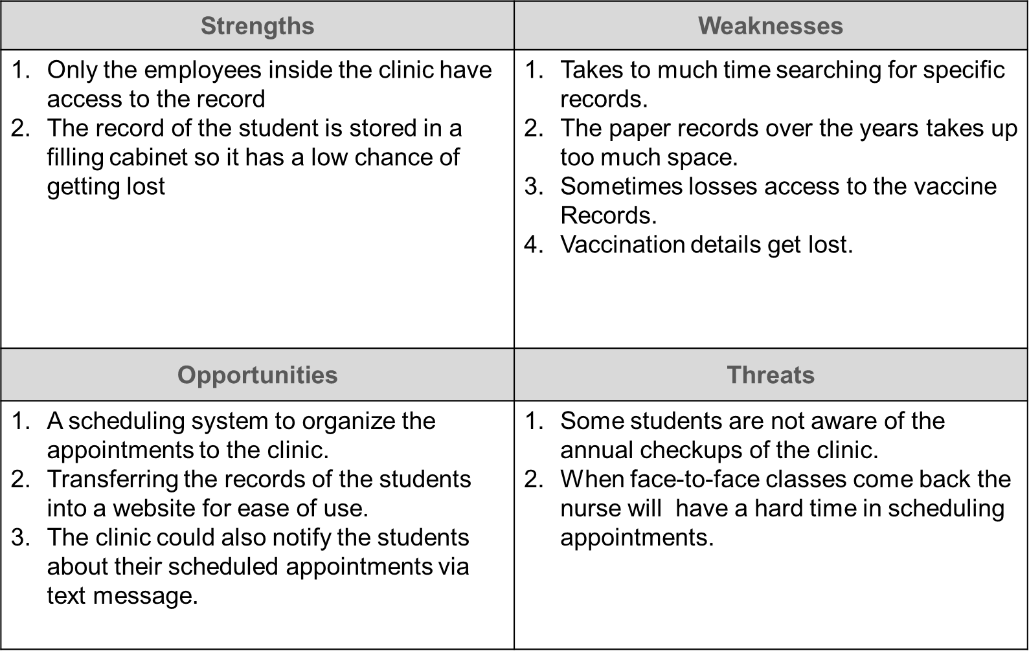

Fig. 2 SWOT Analysis

## System Analysis and Design

### Context Diagram

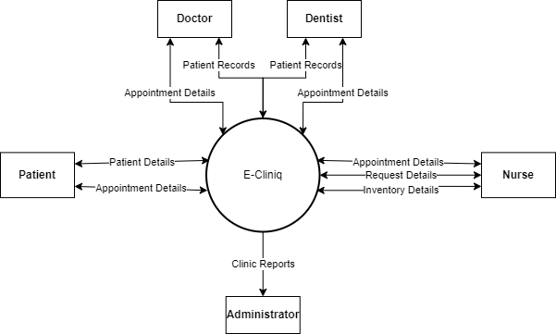

Fig. 3 Context Diagram

### Data Flow Diagrams

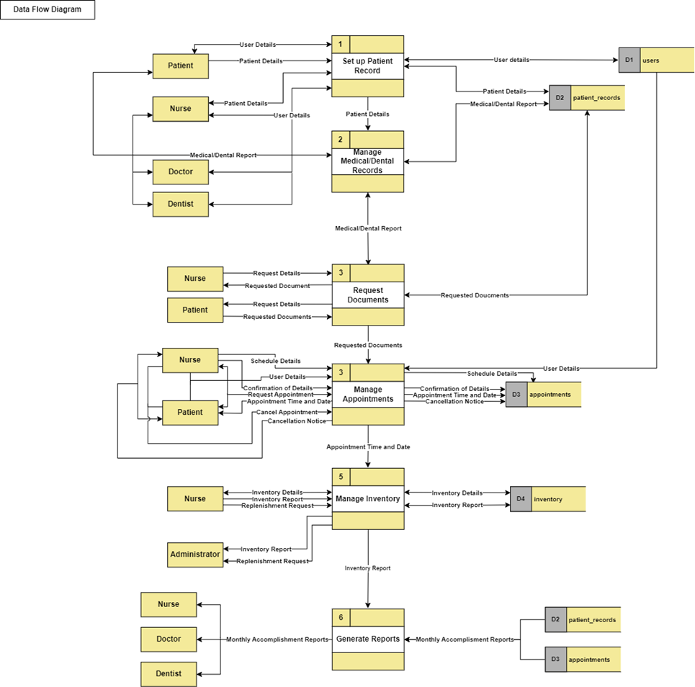

Fig. 4 Data Flow Diagram Level 0

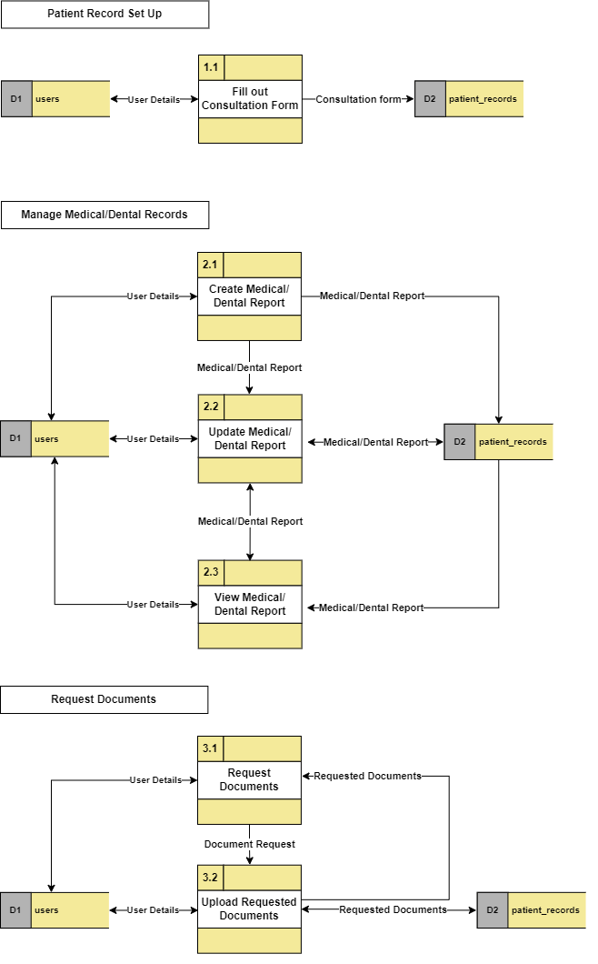

Fig. 5 Data Flow Diagram Level 1 Page 1

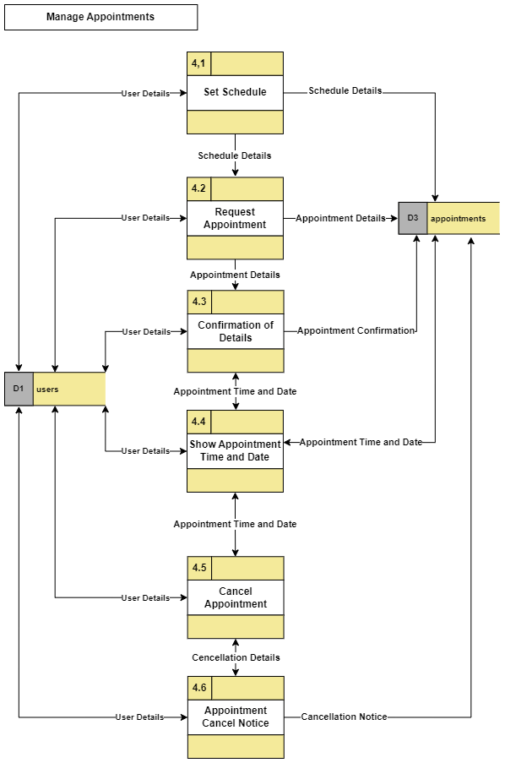

Fig. Data Flow Diagram Level 1 Page 2

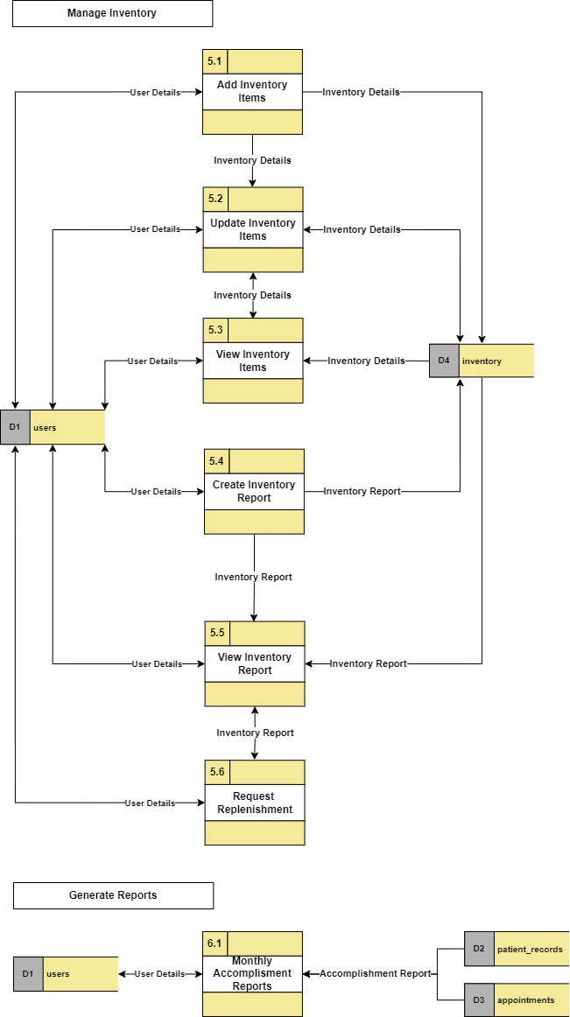

Fig. 7 Data Flow Diagram Level 1 Page 3

### Entity-Relationship Diagrams

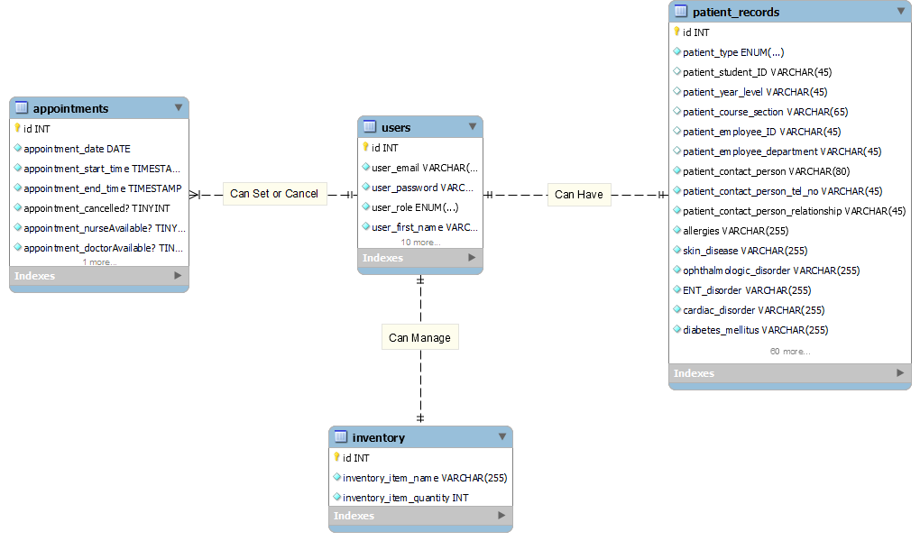

Fig. 8 Entity Relationship Diagram

### Activity Diagrams

Fig. 9 Activity Diagram 1

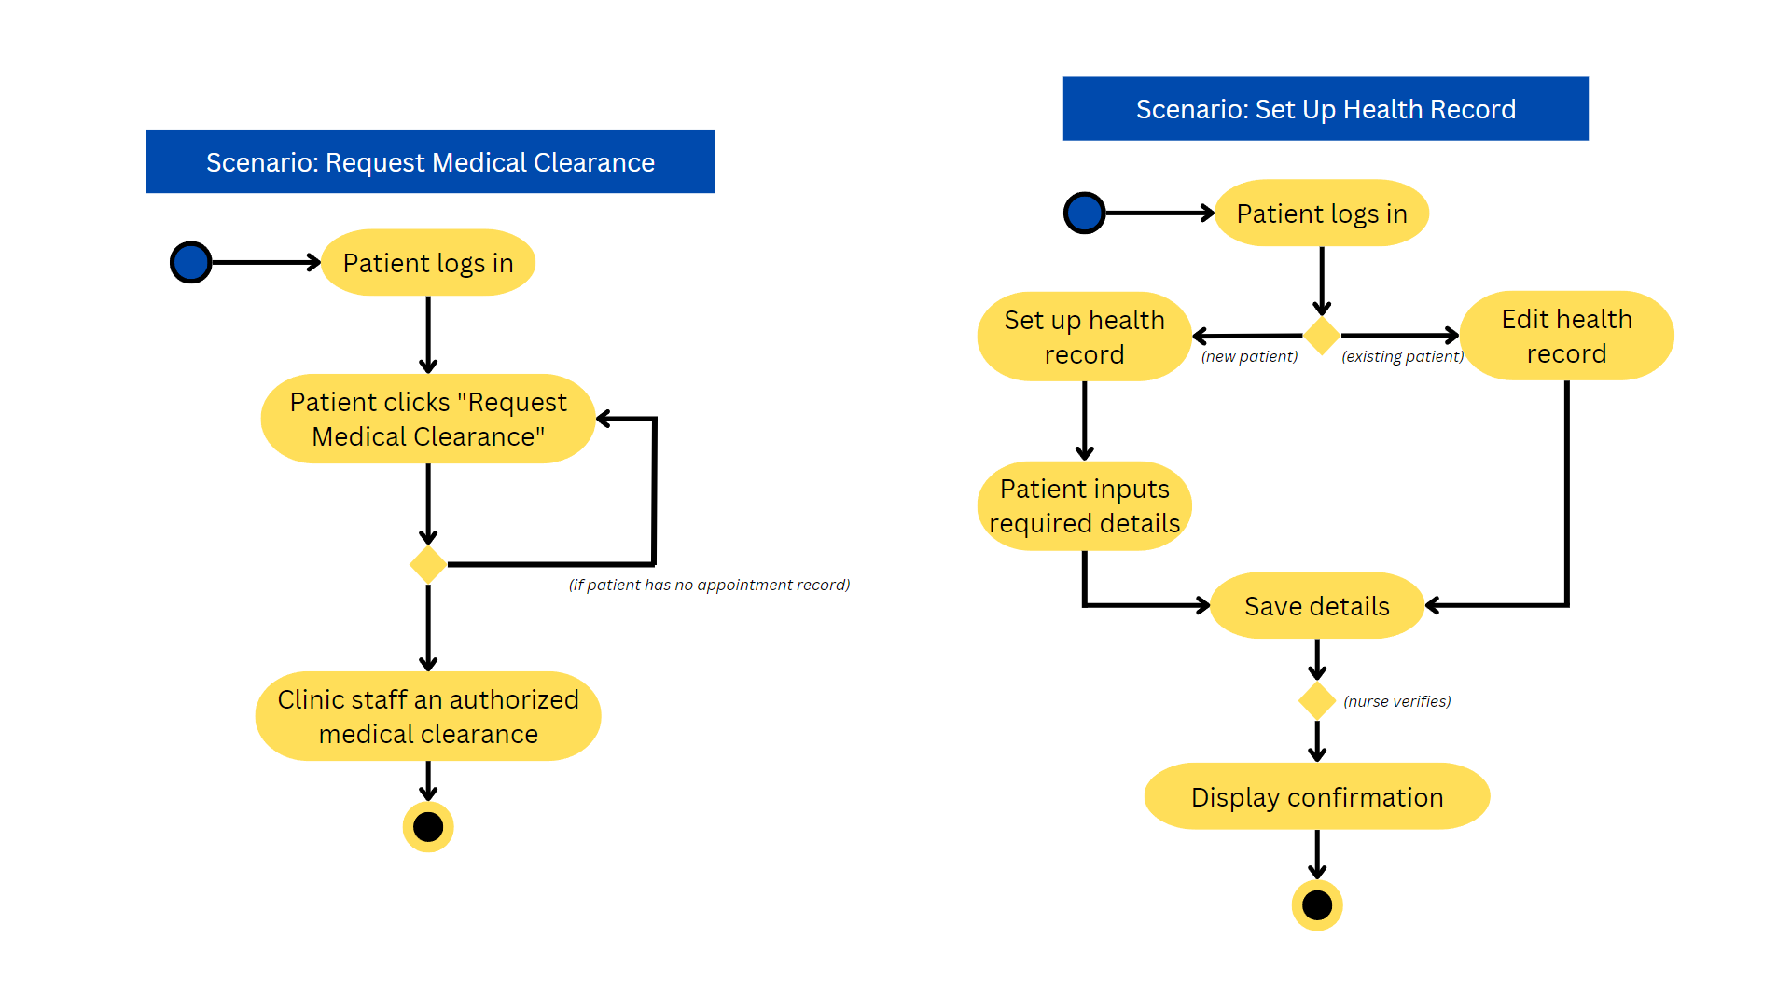

Fig. 10 Activity Diagram 2

### Object Diagrams

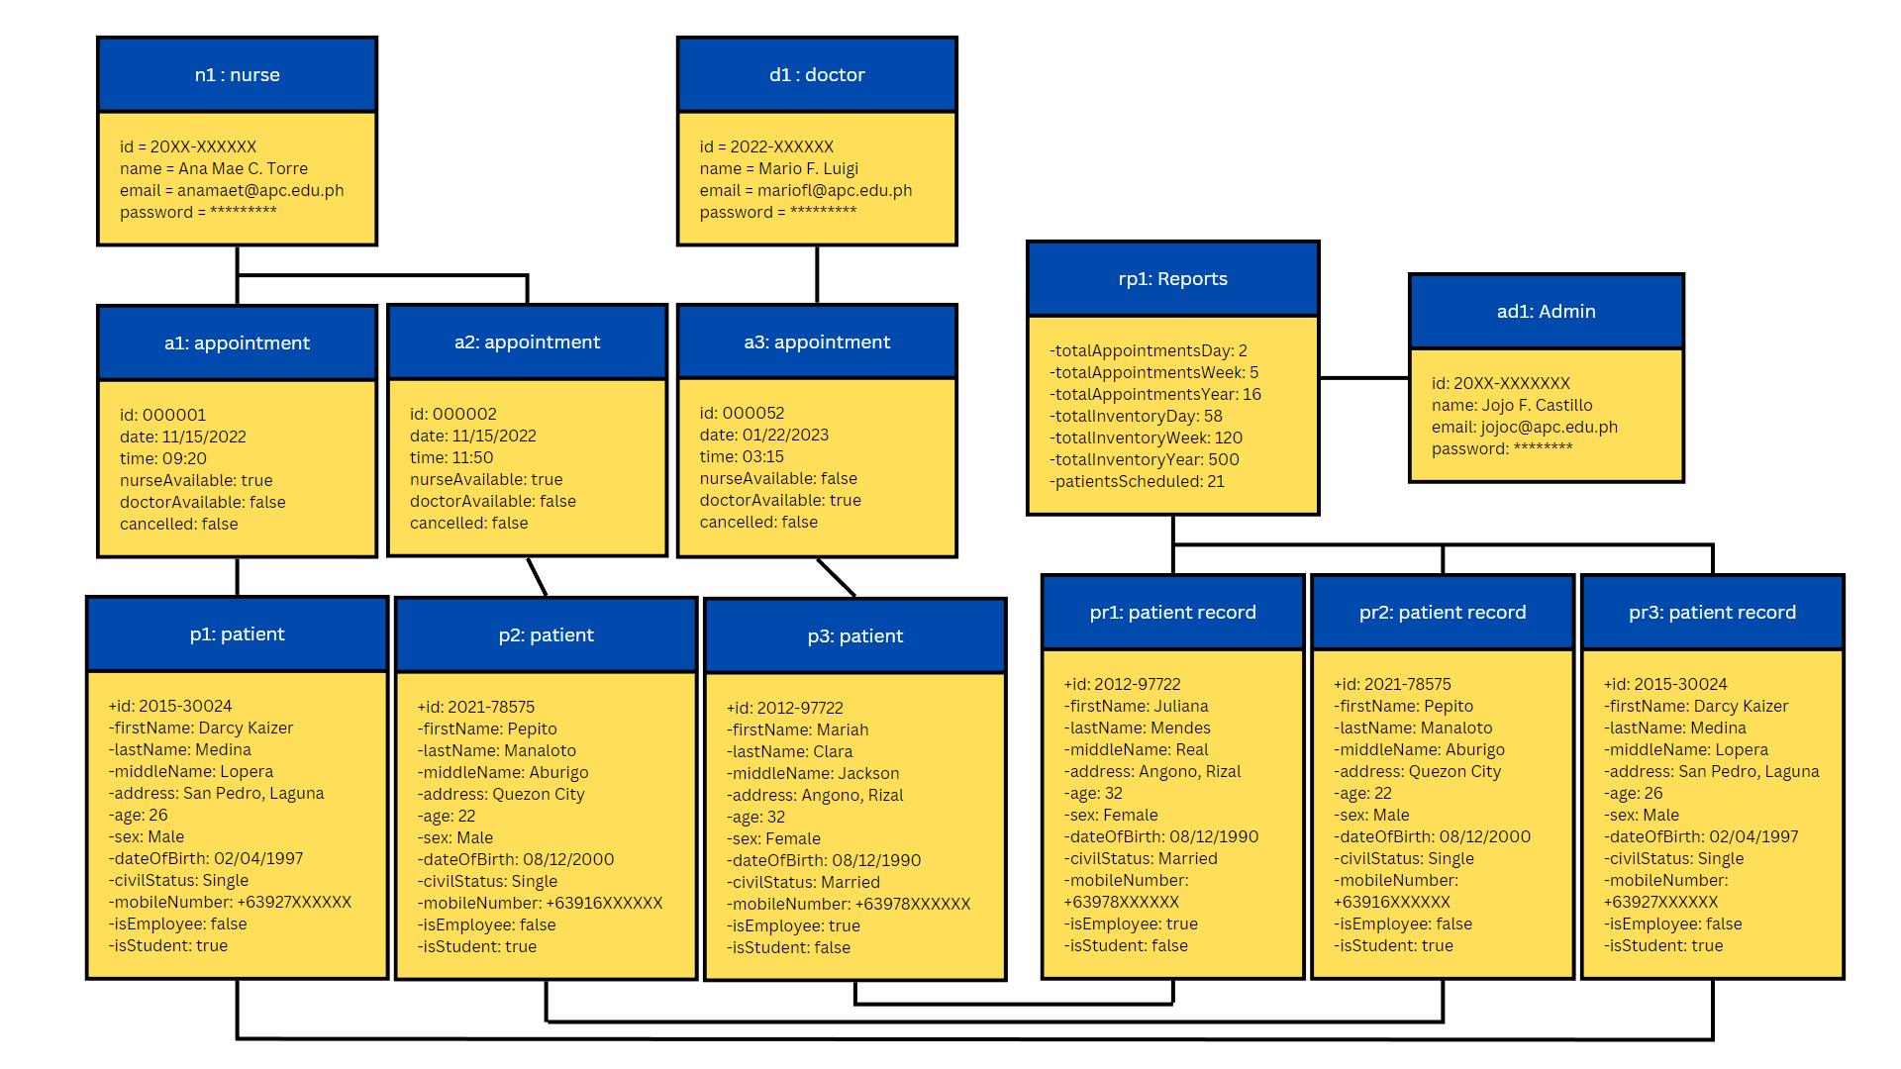

Fig. 11 Object Diagram

### Class Diagrams

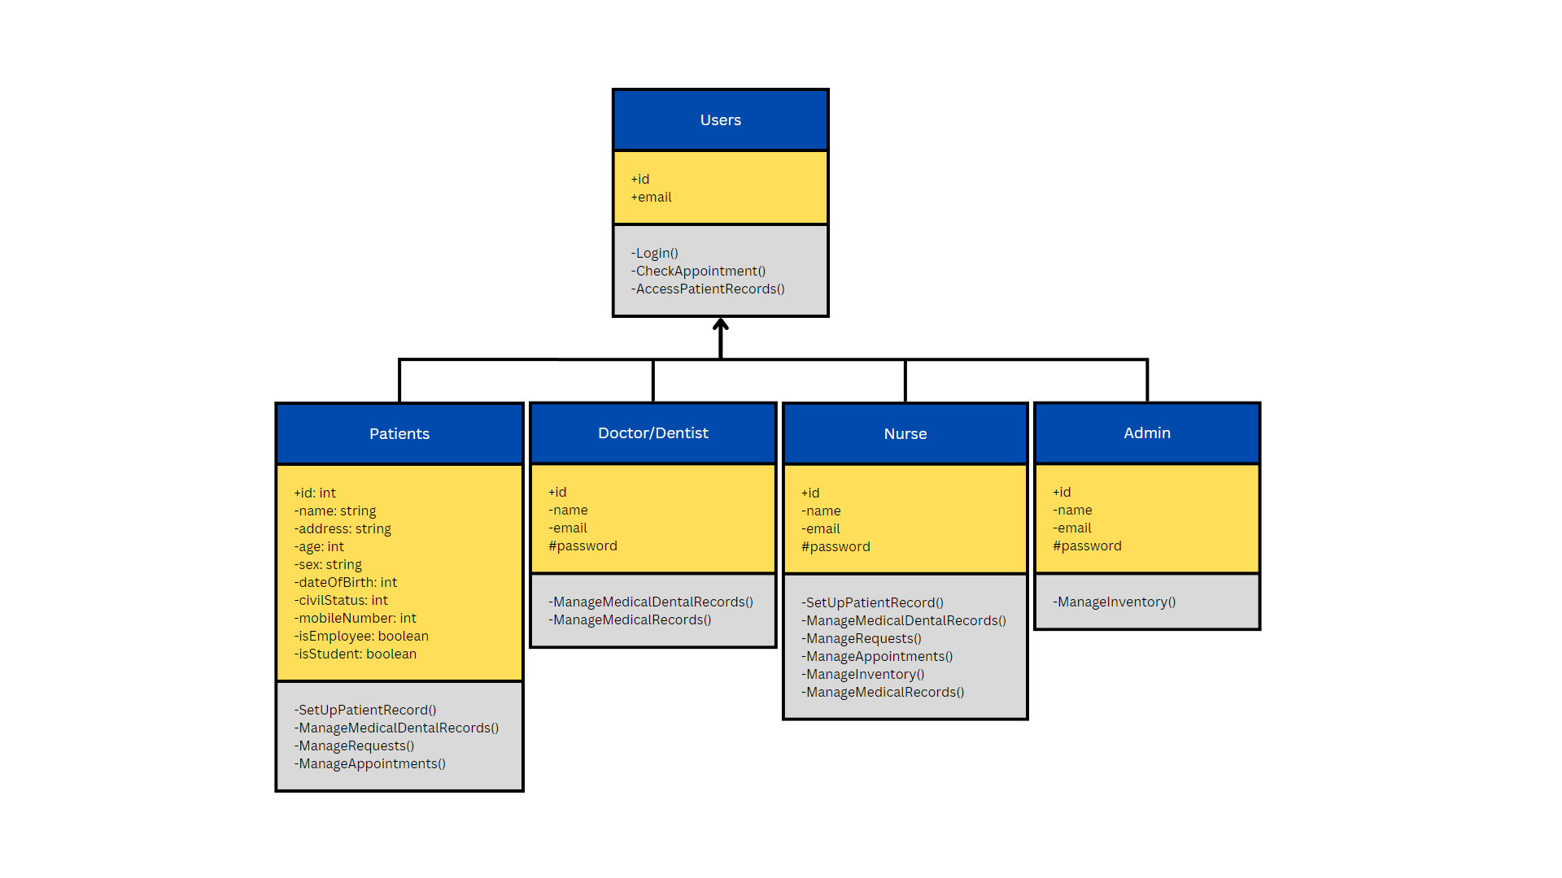

Fig. 12 Class Diagram 1

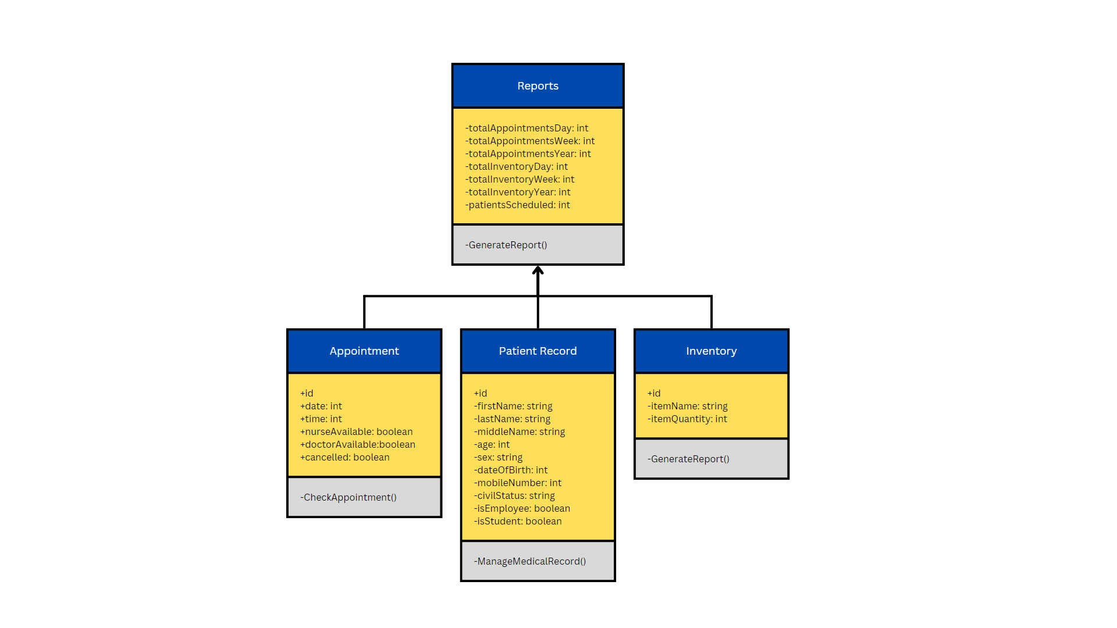

Fig. 13.1 Class Diagram 2

### Sequence Diagrams

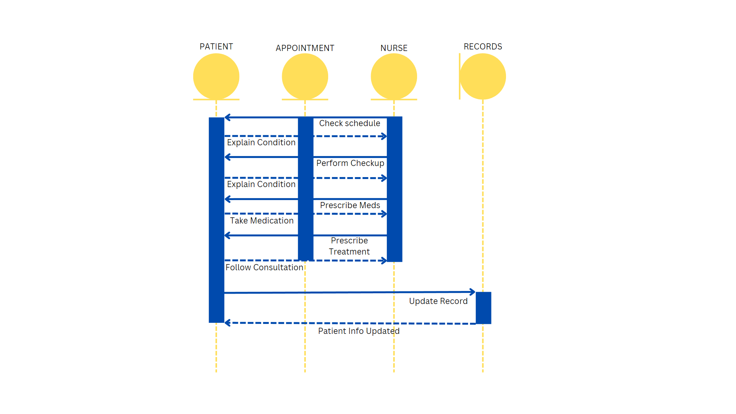

Fig. 14 Sequence Diagram

### State Machine Diagrams

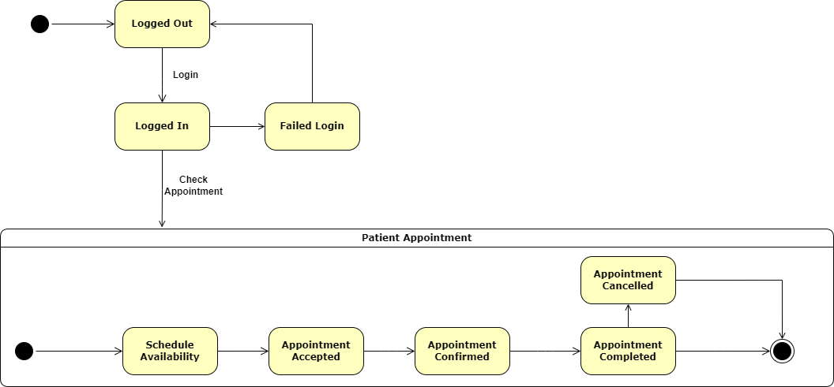

Fig. 15 State Machine Diagram (Patient Appointment)

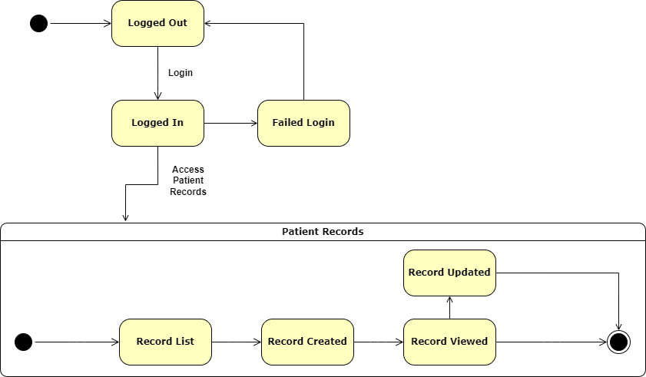

Fig. 16 State Machine Diagram (Patient Records)

# Results and Discussion

The findings of our research and their results are discussed in this chapter. Our analysis addresses the project's goals and delivers a thorough understanding of the research problem. We start by summarizing the data gathered and the techniques applied to analyze it. The results are then presented, and their significance is discussed in relation to earlier studies in the area.

## Release Plan

**Target Group:** APC Clinic

**Goal: To create a web application integrated with the APC database and emails of all APC community personnel.** The system will be able to digitize the clinic’s system by scheduling appointments of patients, managing medical records efficiently, managing inventory for supplies and managing the request of documents.

**Needs:** A web application that will store patient records and digitize them so that the clinic can utilize the space for more clinic utilities.

**Value:** E-CLINIQ will help the nurse to manage and view records and schedules without the hassle of going through stockpiles of documents.

**Key features:** Patient record management, Management of inventory, database, management of appointments, and request management.

**Release 1:**

* Research Paper
* Low-fidelity Prototype
* Proposed Functions and Outputs
* Pitch Video

**Release 2:**

* Hi-Fidelity Prototype
* Design thinking

**Release 3:**

* Database
* Inventory System
* Medical Record storage
* Updating Research Paper
* Final Project Teaser video
* Project sway
* Added framework.
* Setting up domain for temporary public use
* Web design

## Prototype

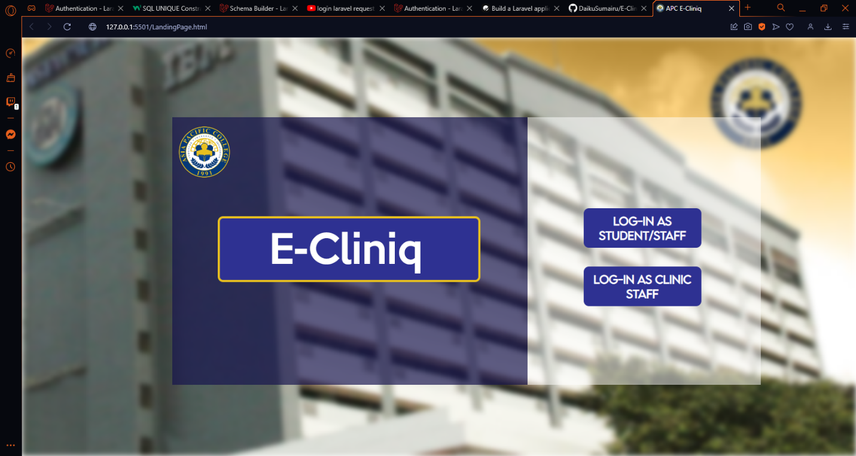

Fig. Landing Page

Landing page where the users can choose between logging in as a student/staff or clinic staff.

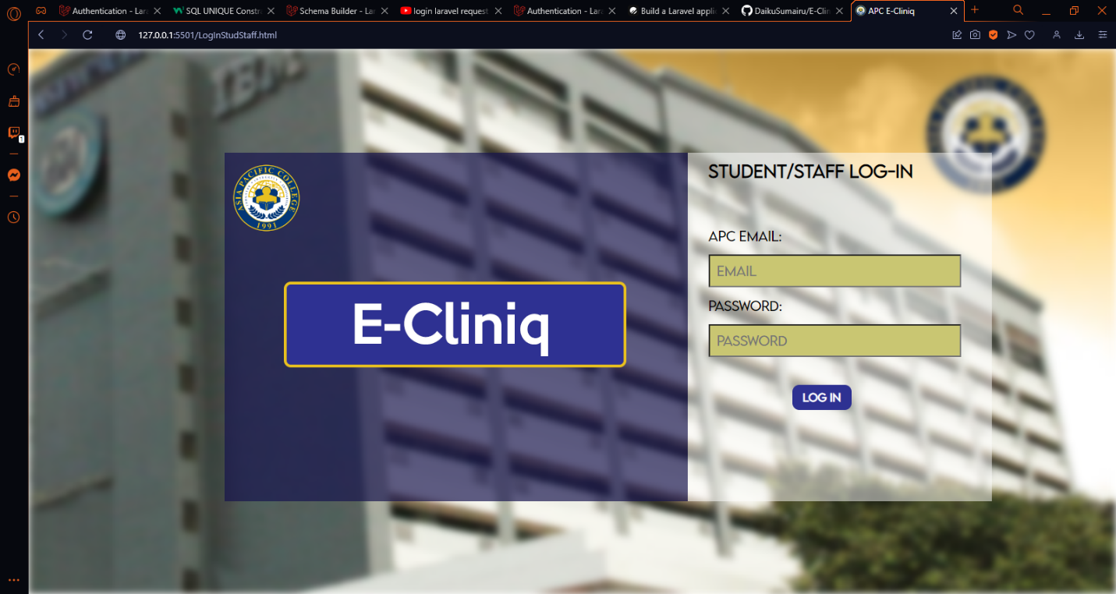

Fig. Patient Login

This is where a patient logs in with his/her RAMs credentials to access the clinic services.

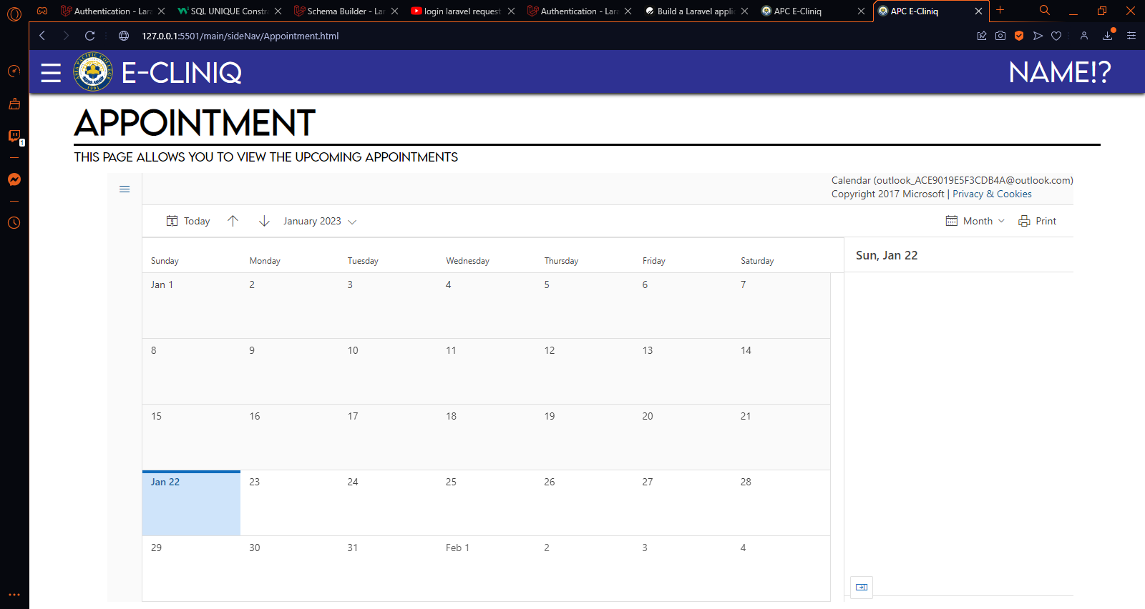

Fig. Appointment

This is where a patient can view available appointments for the month.

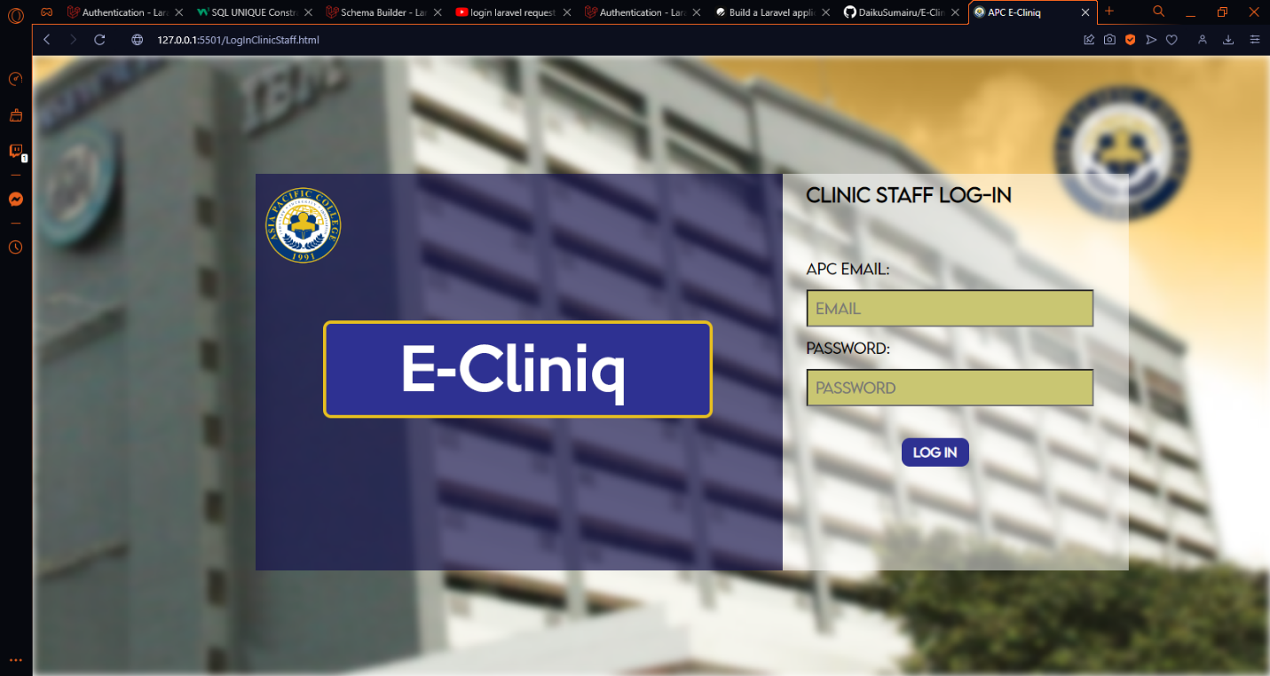

Fig. Clinic Login

This is where the clinic staff, usually the nurse, log in their credentials so that they can access the health records, and update schedule availability.

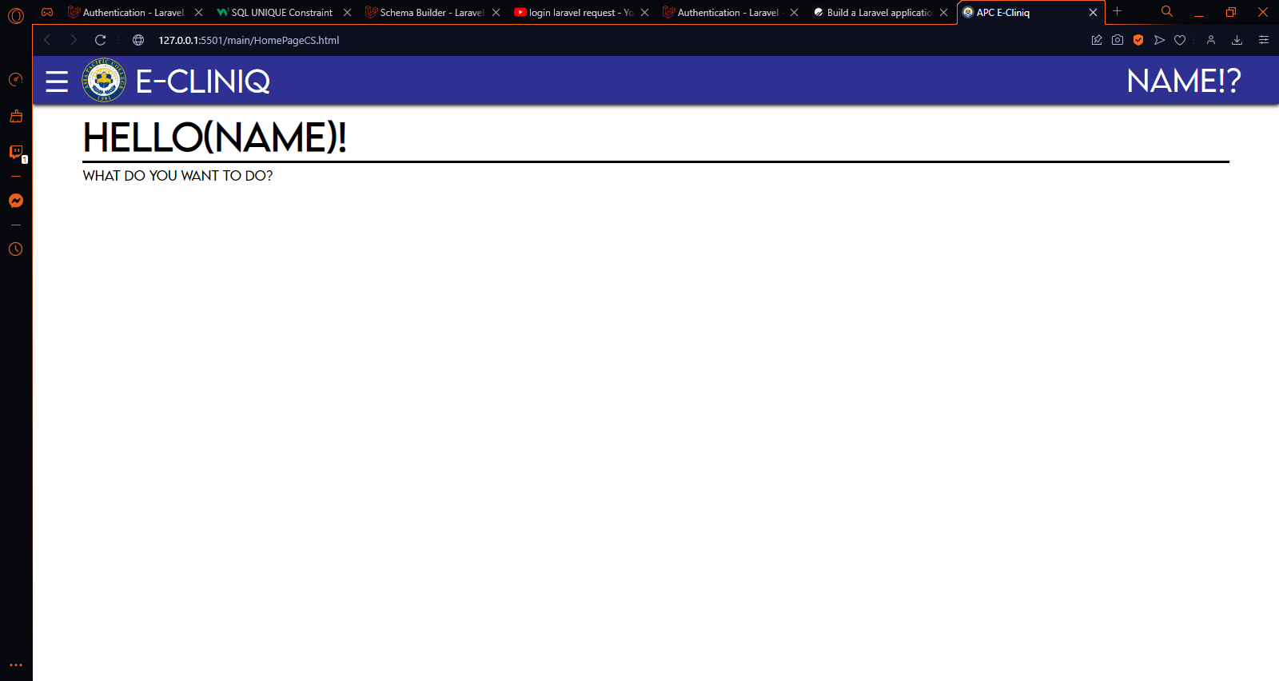

Fig. Clinic Home Page

This is the landing page of the web application’s clinic staff view.

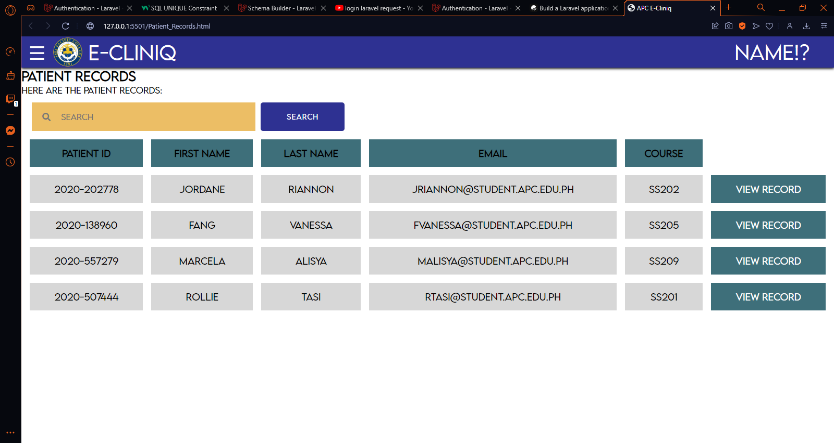

Fig. Patient Records

This is where a clinic staff views and manages patient records. There is a search box wherein the user can search using specific keywords to find the specific record that they are looking for.

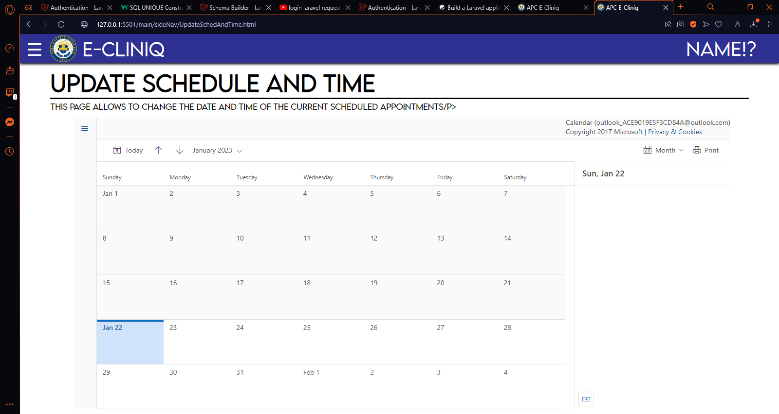

Fig. Update Schedule and Time

This feature allows the nurse to update its operating hours which will then allow the system to reject schedule of appointments during non-operating hours.

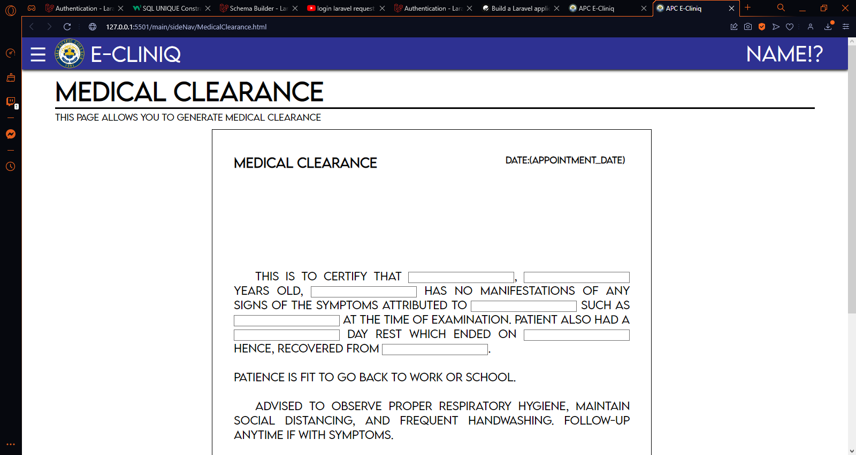

Fig. Medical Clearance

The nurse can issue a medical clearance to students who completed their required physical check-up and dental examination.

## Use Classes and Characteristics

Table 7 User Roles and Description

|  |  |
| --- | --- |
| *Roles* | *Description* |
| *Clinic Administrator* | *This user has access to the summary reports of services generated through the system* |
| *Nurses* | *This user can create, read, update, and delete health records and appointment schedules* |
| *Student* | *This user receives notification about their appointment details through email and text message.* |
| *Employees/ Faculty/ Staff* | *This user receives notification about their appointment details through email and text message.* |

# Conclusion

The first meeting with the client representative, Ms. Ana Mae Torre of APC Clinic, was the first step to this proposed project. The proponents had carefully analyzed the current system that APC Clinic uses, and they noted the client’s pain points in the Statement of the Problem. Related studies also stated how inefficient and costly it is when clinic sticks to a paper system. Accidents can happen and these can destroy or misplace the paper health records, therefore the proposed solution of digitizing the current health record system alleviated the client’s pain points and allows more room for management efficiency. The proponents have concluded that transitioning from a paper system to a cloud system will surely bring benefits to our client while still being economically feasible for the APC clinic. Digitizing the current health record system was not the only scope of this project since the proponents also plan to integrate an appointment system which solves the current hassles of maintaining and recording appointment schedules on a physical logbook. These proposed solutions are technically feasible since the executive director for technical services, Sir Jose “Jojo” F. Castillo, already stated that it is possible for the proposed project to use the existing AWS cloud server that APC currently uses. Amazon also provides security solutions which ensure that the health records will be safe in the cloud. To conclude this paper, E-CLINIQ will enhance the efficiency of the current system and reduce costs as the system will use less paper. The digitized appointment system will also provide a better environment than a simple logbook for managing the schedule of appointments. In SSYADD1, the members become more aware and knowledgeable on the design thinking process wherein we center the project development around our intended users. From there, we gathered input from students, employees, faculty, and staff regarding our initial prototype and took note of their positive and negative feedback. When the team got to SCSPROJ, they began the development of the proposed solution based on diagrams that they made along with it.

# References

|  |  |
| --- | --- |
| [1] | HealthIT.gov, "Benefits of Electronic Health Records," 2017. [Online]. Available: https://www.healthit.gov/topic/health-it-and-health-information-exchange-basics/benefits-ehrs. [Accessed 30 April 2022]. |
| [2] | N. A. o. S. Nurses, "Electronic health records: An essential tool in keeping students healthy," 2019. [Online]. Available: https://www.nasn.org/nasn-resources/professional-practice-documents/position-statements/ps-electronic-health-records. [Accessed 6 June 2022]. |
| [3] | D. S. E. J. J. M. R. P. &. M. F. S. Teodoro, "ORBDA: An openEHR benchmark dataset for performance assessment of electronic health record servers," *PloS one,* no. 13, p. 1, 2018. |
| [4] | SchoolDoc, "SchoolDoc: Electronic Health Record," 15 December 2021. [Online]. Available: https://www.schooldoc.com/electronic-health-record/. [Accessed 6 June 2022]. |
| [5] | EduHealth, "Features: EduHealth," 25 March 2022. [Online]. Available: https://www.eduhealthsystem.com/features/. [Accessed 6 June 2022]. |
| [6] | SimplyBook.me, "Medical Schedulin Software," 2014. [Online]. Available: https://simplybook.me/en/online-appointment-software-for-medical-companies-clinics-doctors-and-healthcare/medical-clinic-appointment-software. [Accessed 6 June 2022]. |
| [7] | Qmatic, "Patient Appointment Systems in Hospitals," 2021. [Online]. Available: https://www.qmatic.com/blog/appointment-systems-in-hospitals. [Accessed 6 June 2022]. |
| [8] | DocPulse, "Appointment Scheduling App for Clinics," 2020. [Online]. Available: https://docpulse.com/products/appointment-management/. [Accessed 6 June 2022]. |
| [9] | StackHawk, "Laravel XSS: Examples and Prevention," 2021. [Online]. Available: https://www.stackhawk.com/blog/laravel-xss/. [Accessed 15 June 2022]. |
| [10] | StackHawk, "Laravel SQL Injection Guide: Examples and Prevention," 2021. [Online]. Available: https://www.stackhawk.com/blog/sql-injection-prevention-laravel/. [Accessed 15 June 2022]. |
| [11] | ReQtest, "How to Make Agile and Waterfall Methodology Work Together," 5 December 2016. [Online]. Available: https://reqtest.com/agile-blog/agile-waterfall-hybrid-methodology-2/#:~:text=The%20Agile-Waterfall%20Hybrid%20is,the%20best%20of%20both%20worlds.&text=The%20hybrid%20method%20retains%20the,adaptability%20and%20flexibility%20of%20agile.. [Accessed 15 June 2022]. |

# Appendices

## Appendix A: Project Vision



Fig. Project Vision for APC Clinic

## Appendix B: Schedule

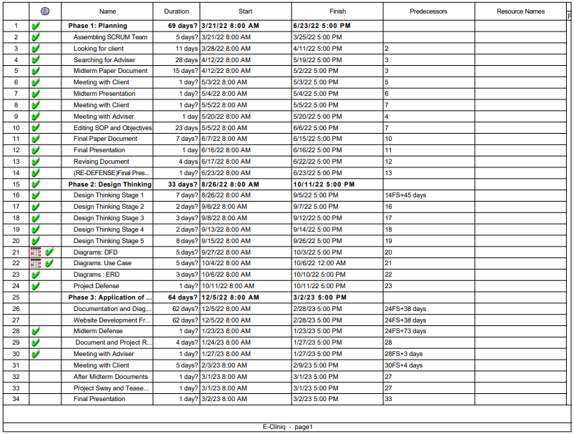

Fig. Gantt Chart (Page 1)

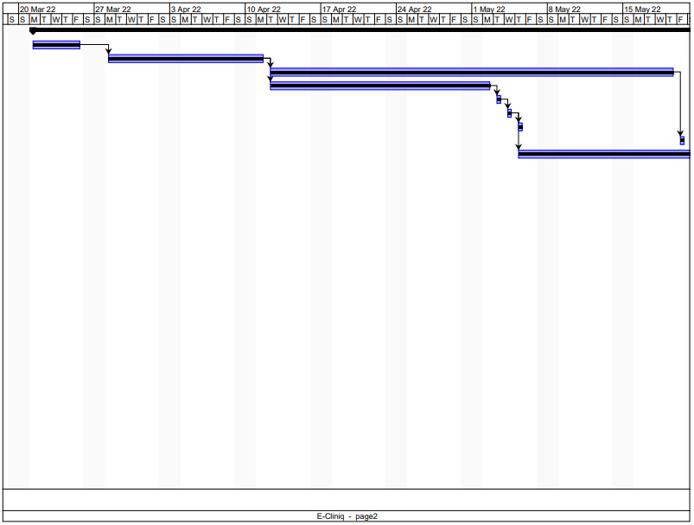

Fig. Gantt Chart (Page 2)

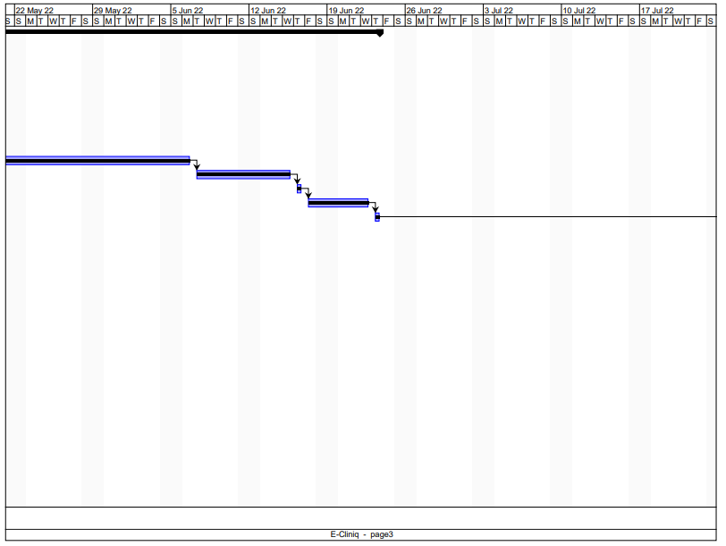

Fig. Gantt Chart (Page 3)

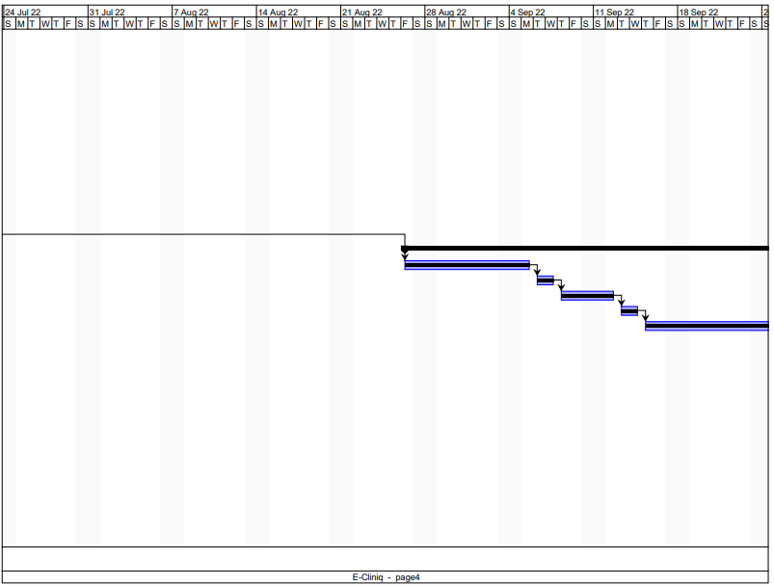

Fig. 29 Gantt Chart (Page 4)

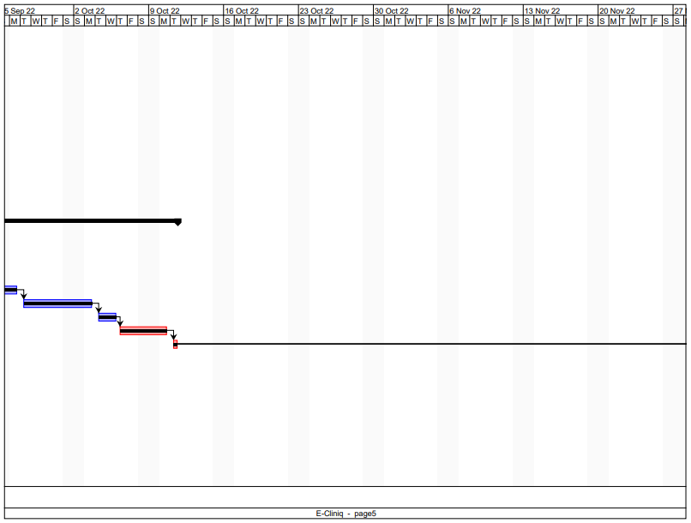

Fig. 30 Gantt Chart (Page 5)

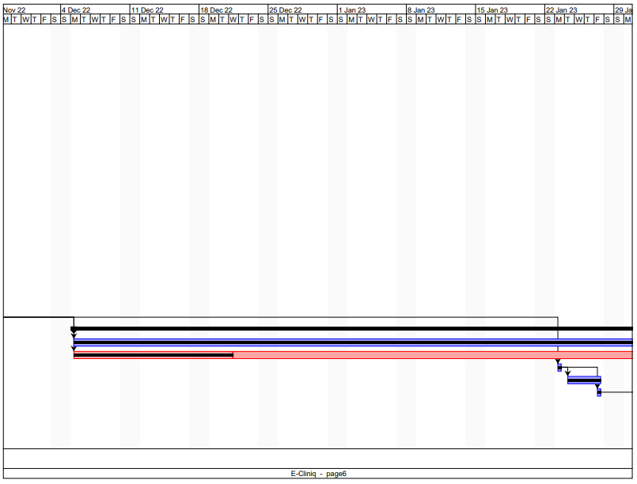

Fig. 31 Gantt Chart (Page 6)

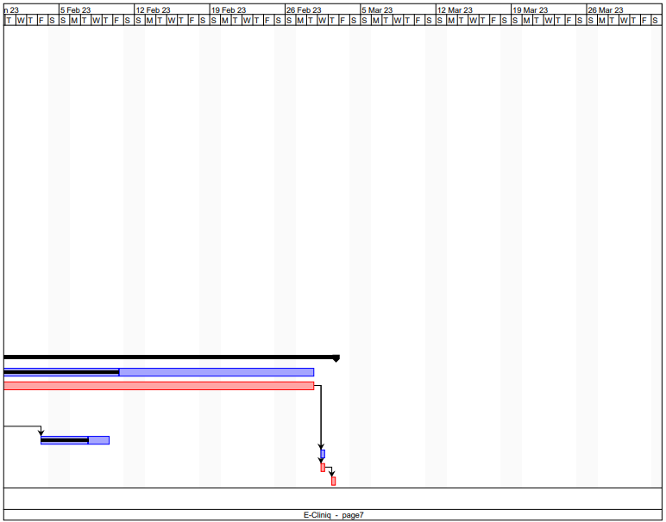

Fig. 32 Gantt Chart (Page 7)

## Appendix C: Product Roadmap

|  |  |  |  |
| --- | --- | --- | --- |
| SNTSDEV | SSYADD1 | SCSPROJ | PROJMAN |
| **Finding a client**   * Choosing APC health clinic as our client * Identifying Client Problems * Client and User Interviews * Proposal of Ideas and solutions   **Project Pitch**   * Documentation * SWOT analysis * Low Fidelity Prototype * Product video | **Design Thinking**  Phase 1  Stage 1   * Empathy map * Customer pain and gain * Customer centric graph * Clinic current process * Clinic pictures   Stage 2   * Clustering Problem Area * Reimagine exercise.   Stage 3   * Crazy 8 exercise * Brainstorm Ideas   Stage 4   * High Fidelity Prototype * Storyboarding   Stage 5   * User reviews   Phase 2  Diagrams   * Use case Diagram. * Data Flow Diagram * Entity Relationship Diagram | **Updated and created diagrams.**   * Use case diagram. * DFD (Data Flow Diagram) * ERD (Entity Relationship Diagram) * Event table * Context Diagram * Sequence Diagram * UML Class Diagram * State machine Diagram * Object Diagram   **Finished Project Document**   * Updated objectives. * Updated Roadmap * Updated Schedule * Project Sway * Final Project Teaser video   **Coding of the Project**   * Database Setting domain for temporary access * Adding Laravel as its framework * Inventory system | •Update and maintenance of the project  •Weekly SMS reminders and notifications  • Integration of APC accounts to the database  •Appointment System  •Connecting to APC systems  •Setting up accounts for users.  •User Reviews, Updates, and bug fixes |

Fig. 27 Product Roadmap

This is the product road map of the project where there are 5 subject areas where we will be updating our project. The first phase is the project where we collected important data to know what to produce for our client, the second is SSYADD where we improved the prototype and improved ideas to innovate the project, the third is where we improved the document while coding of the system, and finally the last is where we will be managing the system, Updates based on user reviews and system integration.

## Appendix E: Team Meetings

Table 8 Minutes of the Meeting

|  |  |  |  |  |
| --- | --- | --- | --- | --- |
| Meeting ID | Date | Participants | Duration | Agenda |
| M001 | April 29, 2022 | Ana Mae J. Torre  Jan Patrick M. Navarrete  Kurt Jordan Cadenas  John Angel Manahan  Darcy Kaizer Medina  Churchill Capagngan | 26 mins and 24 seconds | * Statement of the Project * SWOT Analysis * Objectives * Find adviser |
| M002 | May 18, 2022 | Ana Mae J. Torre  Jan Patrick M. Navarrete  Kurt Jordan Cadenas  John Angel Manahan  Darcy Kaizer Medina  Churchill Capagngan | 32 mins and fifteen secs | * Comment Matrix * Finding adviser * Process of APC Clinic |
| M003 | May 19, 2022 | Manuel L. Calimlim, Jr  Jan Patrick M. Navarrete  John Angel Manahan  Churchill Capagngan | 27 minutes  And 27 seconds | * Statement of the Problem and objective proposal to adviser |
| M004 | May 24, 2022 | Roselle Wednesday L. Gardon  Jan Patrick M. Navarrete  Kurt Jordan Cadenas  John Angel Manahan  Darcy Kaizer Medina  Churchill Capagngan | 16 minutes and 26 seconds | * Survey and SOP progression |
| M005 | May 30, 2022 | Manuel L. Calimlim, Jr  Jan Patrick M. Navarrete  Kurt Jordan Cadenas  John Angel Manahan  Darcy Kaizer Medina  Churchill Capagngan | 19  Minutes  And 31 seconds | * SOP Revision and update |
| M006 | June 3, 2022 | Manuel L. Calimlim, Jr  Jan Patrick M. Navarrete  Kurt Jordan Cadenas  Darcy Kaizer Medina  Churchill Capagngan | 34 minutes  And 5 seconds | * SOP and Objective Revision. |
| M007 | June 6, 2022 | Ana Mae J. Torre  Manuel L. Calimlim, Jr  Jan Patrick M. Navarrete  Kurt Jordan Cadenas  John Angel Manahan  Darcy Kaizer Medina  Churchill Capagngan | 1 hour | * Physical SOP and Objective revision and consultation with grammarian |
| M008 | June 10,  2022 | Jayvee M. Cabardo  Jan Patrick M. Navarrete  Kurt Jordan Cadenas  John Angel Manahan  Darcy Kaizer Medina  Churchill Capagngan | 41 minutes | * SOP and Objective Consultation * Economic and Technological Feasibility of the project |
| M009 | June 13, 2022 | Roselle Gardon  John Angel Manahan | 13 minutes | * Consultation with SOP and Objectives. * Rechecking of Scope and Limitations * Add supporting literature and applications to justify SOP and Objective |
| M0010 | June 14, 2022 | Jojo Castillo  Jan Patrick M. Navarrete  Kurt Jordan Cadenas  Darcy Kaizer Medina  Churchill Capagngan | 19 minutes | * Economic and technological Feasibility of our proposed solution * Servers operating in APC. * The Cost of operation of the Technology. |
| M011 | June 15, 2022 | Jayvee M. Cabardo  Jan Patrick M. Navarrete  Kurt Jordan Cadenas  John Angel Manahan  Darcy Kaizer Medina  Churchill Capagngan | 9 minutes | * Consultation of the Paper and the feasibility of our project. |
| M012 | June 21, 2022 | Manuel L. Calimlim, Jr  Jan Patrick M. Navarrete  Kurt Jordan Cadenas  John Angel Manahan  Darcy Kaizer Medina  Churchill Capagngan | 1 hour and 14 minutes | * Reviewing of panelist comments during the final presentation. * Planning of response for the re-defense |
| M013 | June 22, 2022 | Jojo Castillo  Jan Patrick M. Navarrete  Kurt Jordan Cadenas  Darcy Kaizer Medina  Churchill Capagngan | 1 hour and 6 minutes | * Reviewing of panelist comments about the clinic processes |
| The meetings included in this table are group meetings, meetings with the adviser, and meeting with the clients. | | | | |

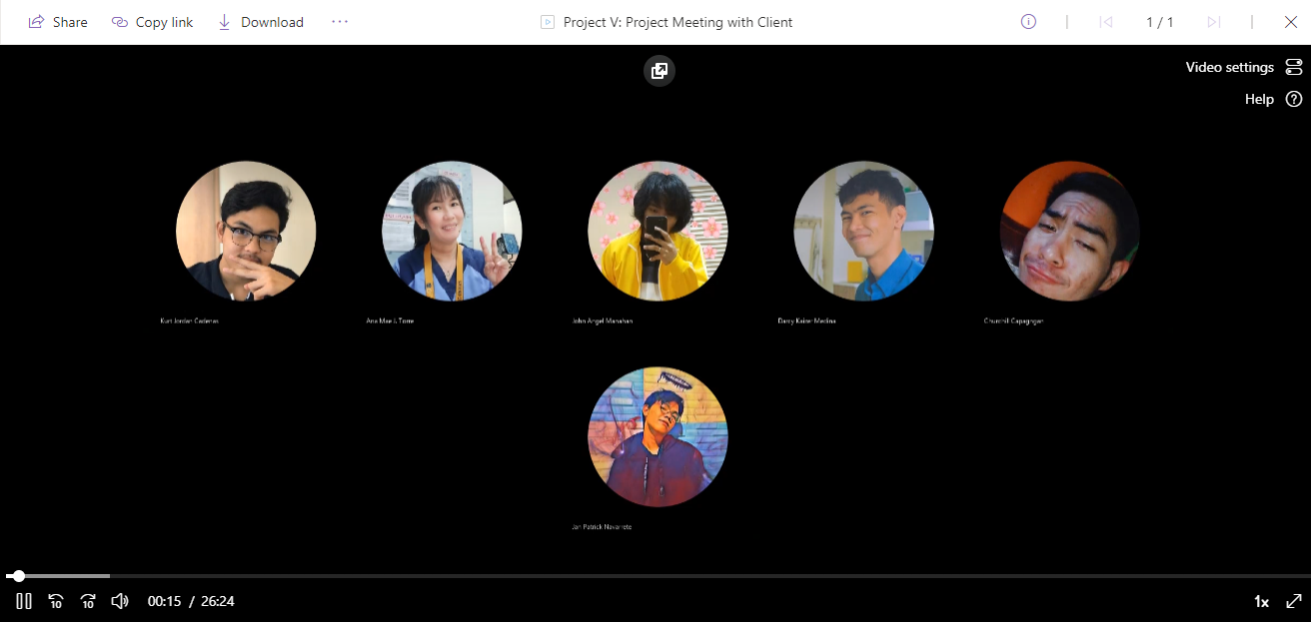

Fig. 33 First Meeting with Nurse Ana Mae Torre (April 29, 2022)

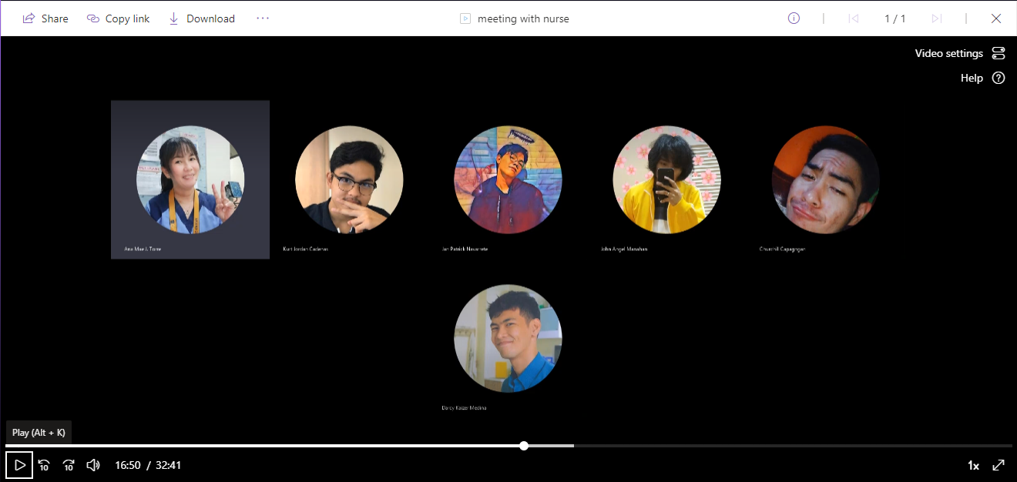

Fig. 34 Second Meeting with Nurse Ana Mae Torre (May 18, 2022)

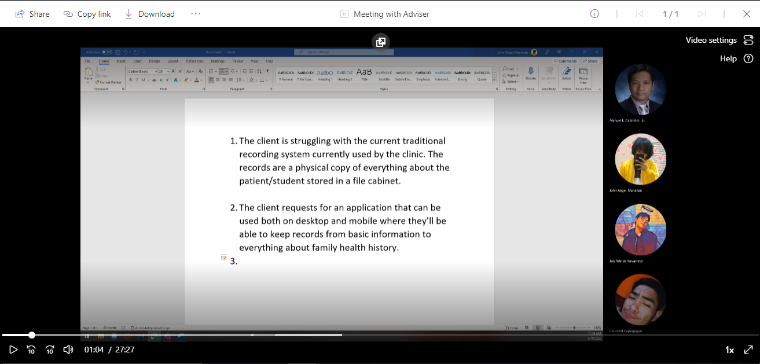

Fig. 35 First Meeting with Project Adviser, Doc Manny (May 19, 2022)

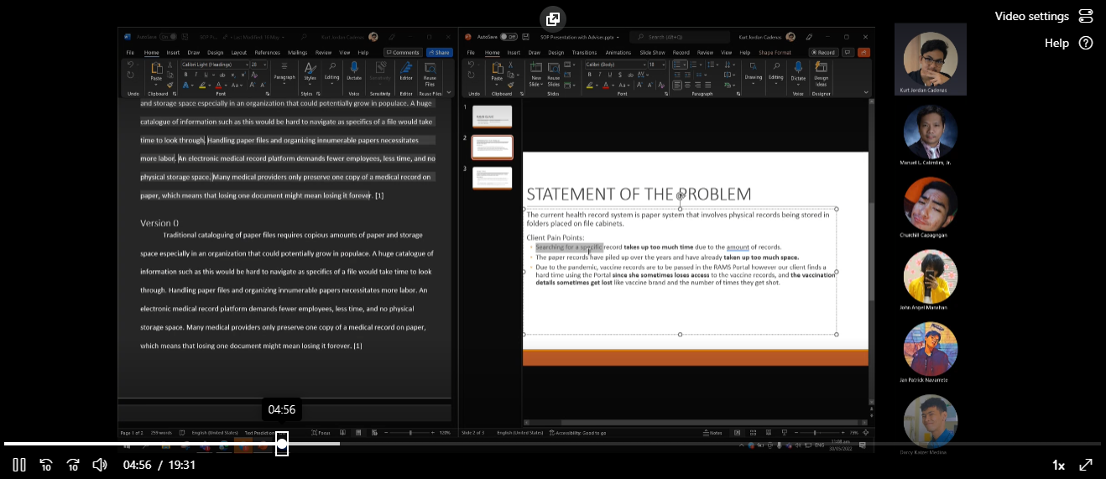

Fig. 36 Second Meeting with Project Adviser (May 30, 2022)

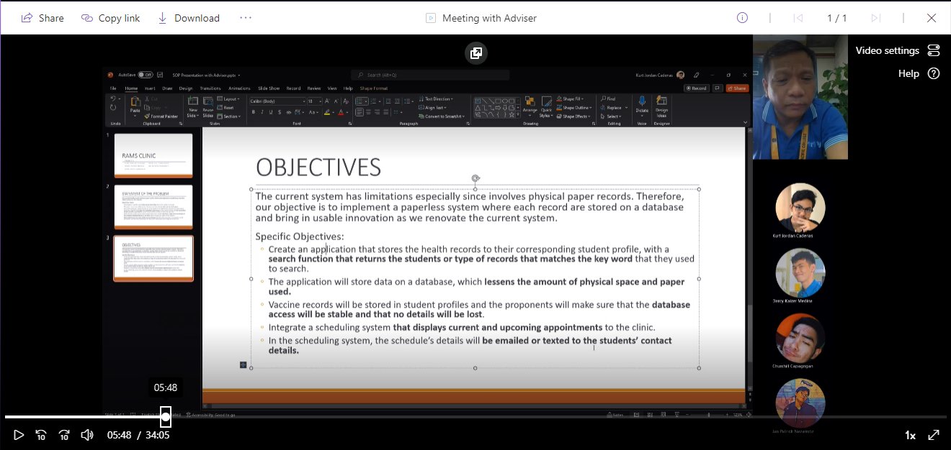

Fig. 37 Third Meeting with Project Adviser (June 3, 2022)

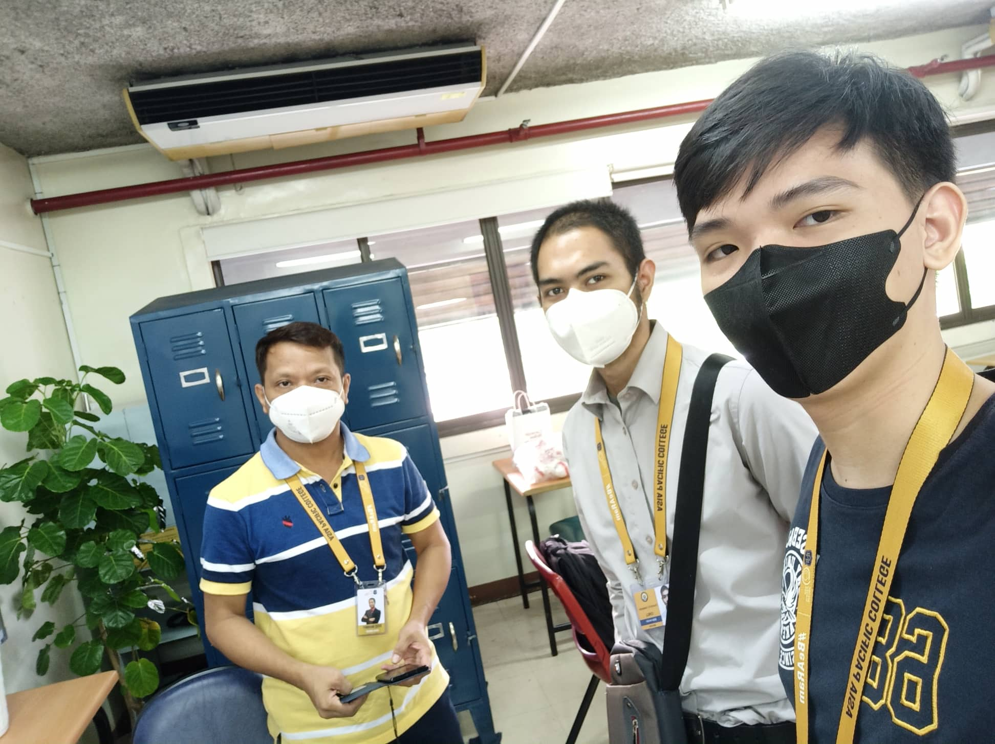

Fig. 38 Physical Meeting with Project Adviser (June 6, 2022)

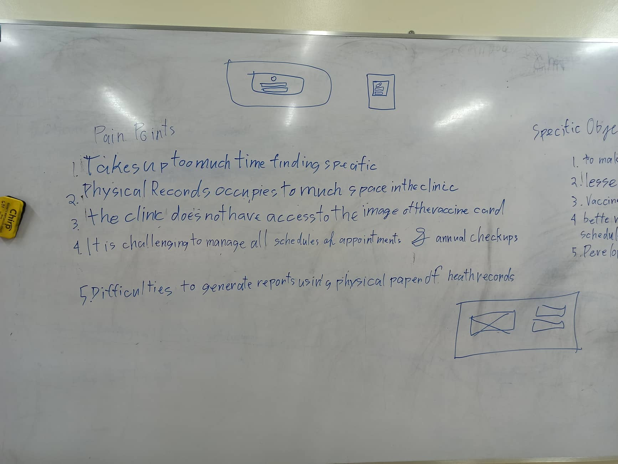

Fig. 39 Project Discussion on Whiteboard (June 6, 2022)

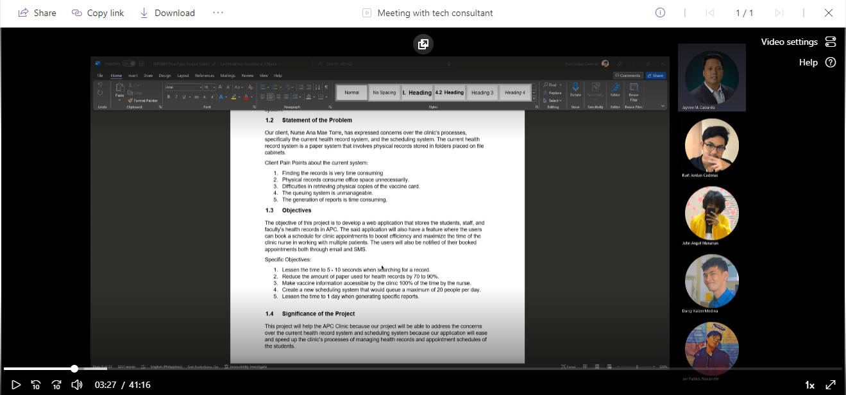

Fig. 40 Meeting with Technical Consultant, Sir Jayvee (June 10, 2022)

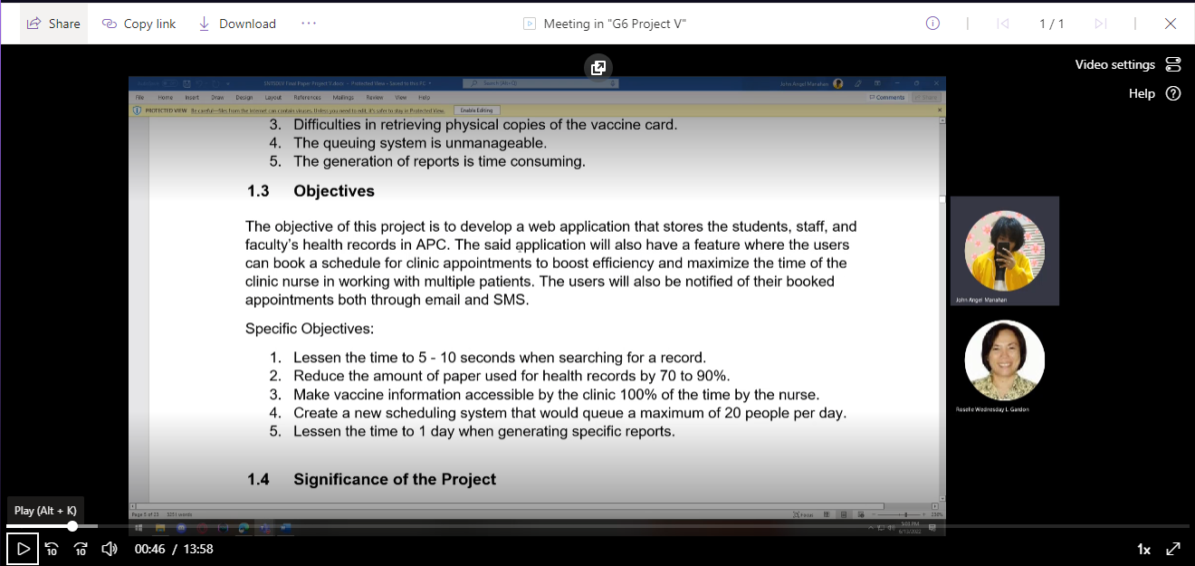

Fig. 41 Meeting with Subject Adviser, Ms. Roselle (June 13, 2022)

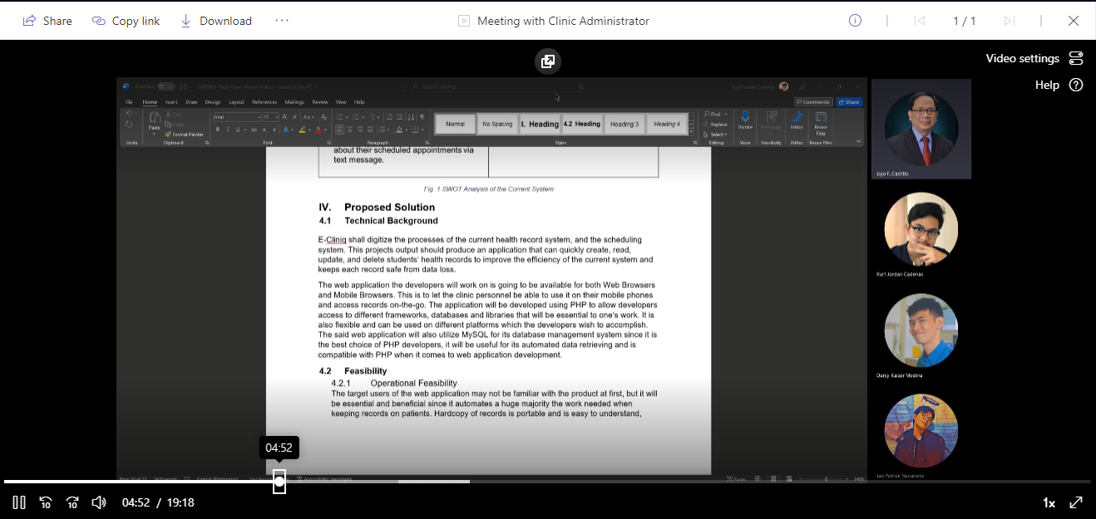

Fig. 42 Meeting with Clinic Administrator, Sir Jojo (June 14, 2022)

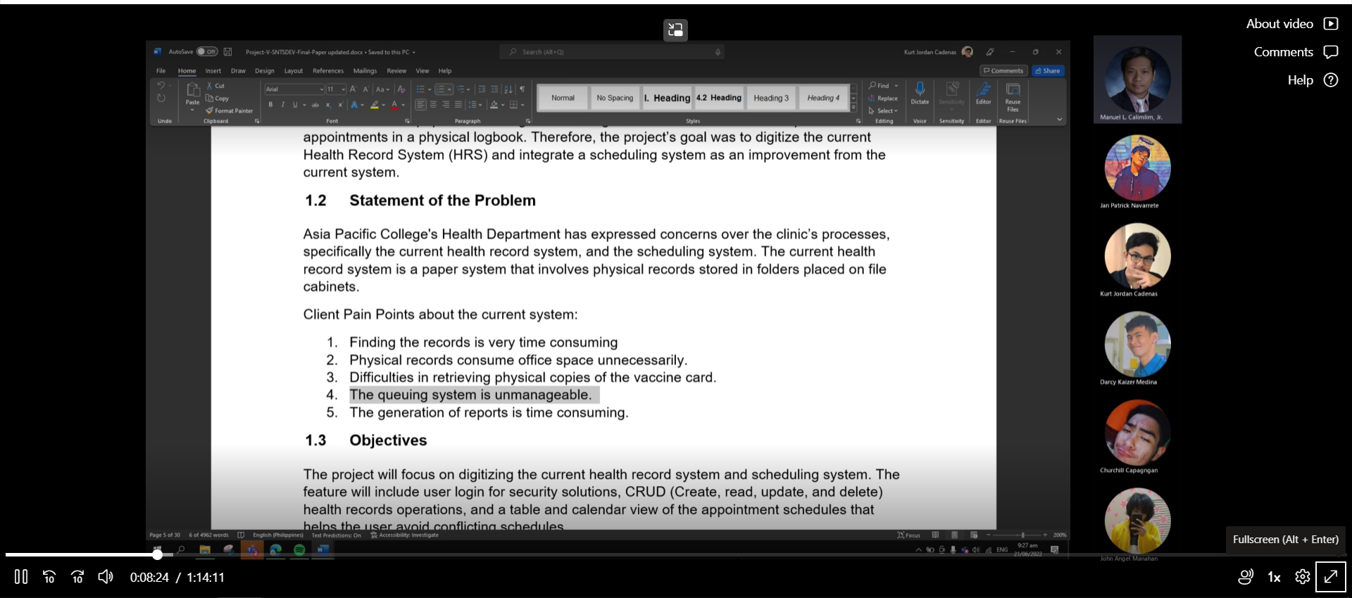

Fig. 43 Meeting with Project Adviser (June 21, 2022)

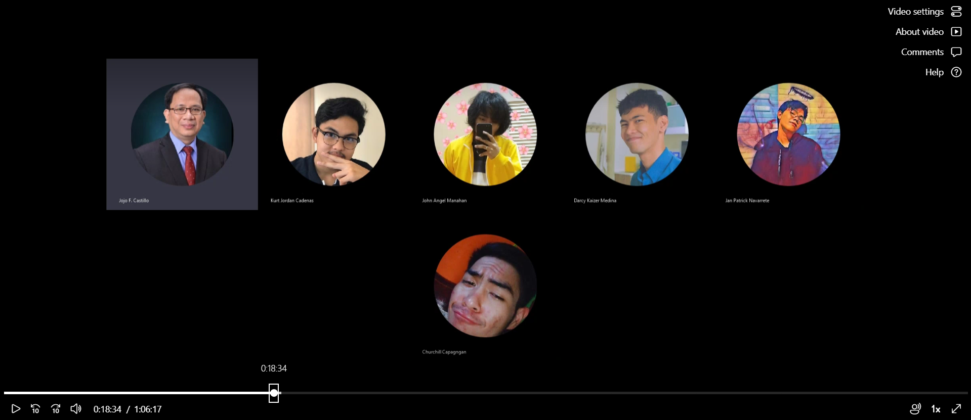

Fig. 44 Meeting with Clinic Administrator (June 22, 2022)

## Appendix F: Source Code

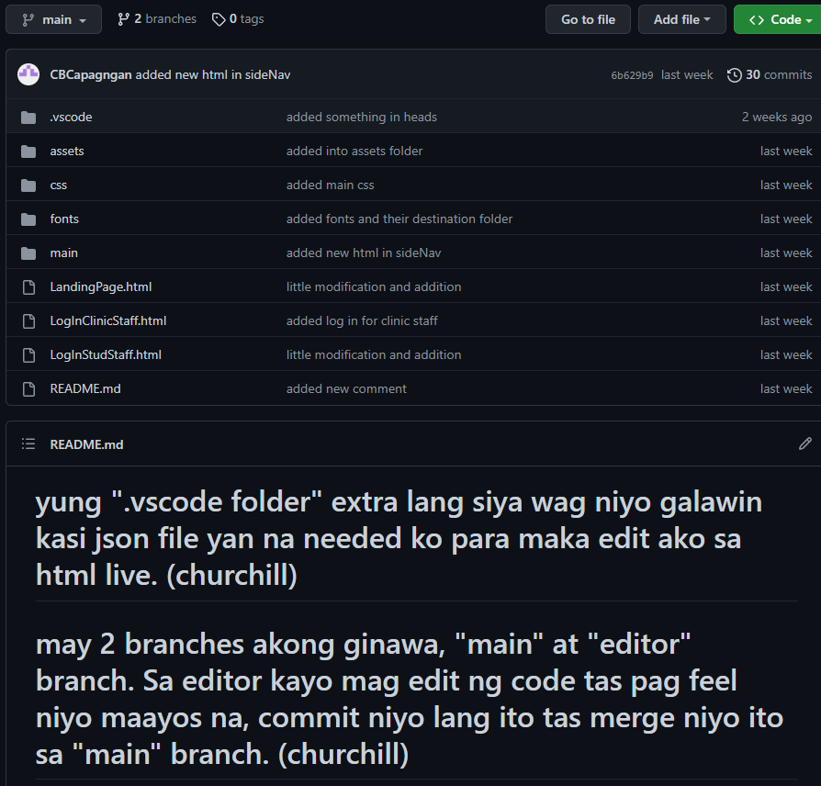

Fig. 45 GitHub Repository

Link: <https://github.com/DaikuSumairu/E-Cliniq>

Kurt Jordan V. Cadenas

General Trias, Cavite. Philippines.

Email: [kurtcadenas1029@gmail.com](mailto:kurtcadenas1029@gmail.com) | 0929-220-9820 |

Skills Summary

* Web Development Programming (HTML/CSS)
* MySQL & PHP
* Java & Java Programming
* Critical Thinking
* Adept at Formal Communications

Education

***BS Computer Science, Major in Software Systems***

*2020 – 2024*

*Asia Pacific College*

***Senior High School***

*2018 – 2020*

*Taguig Science High School*

***Junior High School***

*2014 – 2018*

*Taguig Science High School*

**John Angel Manahan**

Quezon City, Metro Manila. Philippines

Email: [shutterspacee@gmail.com](mailto:shutterspacee@gmail.com) | 0945-704-5775 / +63939-612-7333 |

Skills Summary

* Graphic Design, Digital Art
* Content Writing
* CSS
* N5 Japanese-Language Proficiency Test

Education

***BS Computer Science, Major in Software Systems***

*2020 – 2024*

*Asia Pacific College*

***IT (Information Technology) in Mobile App and Web Development***

*STI College Cubao*

*2016 – 2018*

Work Experience

***Freelance artist Art by Otosaka (Owner).***

*2019 – Present*

*•* *Vroid 3D Model Artist*

*•* *Live2D Rigger*

*•* *UI/UX Artist*

***Order Entry Specialist of Havenly Inc.***

*2018 – 2019*

*•* *Handles excel spreadsheets for customer orders*

*•* *Assisted customers with invoicing*

**Churchill B. Capagngan**

Pasay City, Metro Manila. Philippines.

Email: [cbcapagngan@gmail.com](mailto:jpnavarrete420@gmail.com) | 0961-938-9923|

Skills Summary

* Web Development Programming (HTML/CSS)
* Mastery in Python, Java, C++, JavaScript, and MySQL.
* Is a Critical and analytical Thinker.
* Well versed in English and Tagalog

Education

***BS Computer Science, Major in Software Systems***

*2020 – 2024*

*Asia Pacific College*

***Science, Technology, Engineering, and Mathematics***

*Asia Pacific College*

*2018 – 2020*

***Junior High School***

*Santa Clara Parish School*

*2014 – 2018*

**Jan Patrick M. Navarrete**

Makati City, Metro Manila. Philippines.

Email: [jpnavarrete420@gmail.com](mailto:jpnavarrete420@gmail.com) | 0915-450-8177 |

Skills Summary

* Web Development Programming (HTML/CSS)
* Mastery in Python, Java, C++, JavaScript, and MySQL.
* Is a Critical and analytical Thinker.
* Well versed in English and Tagalog
* Able to adapt to demanding situations.

Education

***BS Computer Science, Major in Software Systems***

*2020 – 2024*

*Asia Pacific College*

***Science, Technology, Engineering, and Mathematics***

*Asia Pacific College*

*2018 – 2020*

***Junior High School***

*Makati High School*

*2014 – 2018*

**Darcy Kaizer L. Medina**

San Pedro, Laguna. Philippines.

Email: [darkey.medina@gmail.com](mailto:darkey.medina@gmail.com) | 09273920205 |

Skills Summary

* Well versed in English and Tagalog
* Able to translate complex material into easily understandable format.
* Intermediate proficiency in Microsoft Office
* Web Development (HTML/CSS)
* Programming Languages (Python/Java)

Education

***BS Computer Science, Major in Software Systems***

*Jan. 2015 – April 2015, August 2020 - Present*

*Asia Pacific College*

Work Experience

**IBEX Global BF Paranaque**

Advanced Tech Support/Customer Service Representative